# IMPOZITAREA VENITURILOR PERSOANELOR FIZICE ȘI CONTRIBUȚIILE SOCIALE

Aura-Lăcrimioara Lupuț

Universitatea Tehnică din Cluj-Napoca

Faculty of Sciences

Specialization: Business Economics

Email: [luputaura@yahoo.com](mailto:luputaura@yahoo.com)

Ioana-lavinia pleșa (safta)

Universitatea Tehnică din Cluj-Napoca

Faculty of Sciences

Department of Economical Science and Physics

Email: [lavinia_15@yahoo.com](mailto:lavinia_15@yahoo.com) **Abstract**

*The paper presents the theoretical, legal, and practical framework regarding the taxation of individual income and social contributions in Romania, aiming to understand the taxation mechanisms, analyze recent fiscal outcomes, and draw conclusions about the efficiency of the tax system.*

**Keywords:** icome tax, taxpayer, Fiscal Code, fiscal system, Romania



## Introduction

Income tax represents one of the main sources of revenue for the state budget, playing a crucial role in supporting public expenditures and maintaining macroeconomic stability [1]. In Romania, this type of tax has a significant history, evolving from rudimentary forms in the interwar period to the implementation of a flat 10% rate starting in 2018 [2]. In the context of modernizing and digitizing the tax administration, Romanian authorities have carried out numerous reforms to improve tax collection and reduce tax evasion [3].

Essentially, income tax is an instrument for income redistribution, serving multiple functions: financial, economic, and social [4]. It applies to income earned by individuals from various sources—such as salaries, self-employment, rent, investments, pensions, and others—and is governed by the Fiscal Code and the Code of Fiscal Procedure. Romania currently applies a predominantly proportional tax system, with certain differentiated deductions that move it toward a semi-progressive model [5].

This paper aims to analyze the theoretical and legal framework of income tax, the method of applying and calculating tax obligations, and the evolution of Romania’s taxation system during the 2023–2025 period. It also highlights the social and economic implications of this tax and formulates conclusions regarding the efficiency and sustainability of the current fiscal system [6].

## Preliminary section

1. **Literature review**

The specialized literature on taxation and income tax highlights the central role this instrument plays in the functioning of the state. Tax is defined as a mandatory levy, imposed without immediate consideration, by public authority for the purpose of covering public expenditures [7]. It is emphasized that taxes do not involve any direct return from the state and are established by law, being non-refundable and obligatory. They are applied based on the taxpayer’s ability to pay, regardless of the direct benefits received. The principles of taxation, formulated as early as the 18th century by Adam Smith, remain valid today: equity, certainty, convenience, and efficiency. Thus, the tax system must be predictable, fair, and easy to implement [7]. In Romania, the legislation governing income tax is regulated by the Fiscal Code, currently enforced through Law no. 227/2015, which defines taxpayers, categories of taxable income, applicable rates, and calculation methods. The literature emphasizes the difficulty of balancing the complexity of the tax system with the need for clarity for taxpayers [8]. Clearly defining the taxable object and the tax base is essential for fair taxation. The Fiscal Code details taxable income, exemptions, and possible deductions, offering a comprehensive overview of the methods of taxation [9]. Recent studies approach the personal income tax system from a practical perspective, with a focus on liberal professions, freelancers, and investors, highlighting the need for digitalization and transparency in the declaration and payment process [10]. Thus, the literature emphasizes both the theoretical and practical importance of income tax, as well as the challenges related to its application in various economic and social contexts.

1. **Methodology**

To conduct the study on individual income taxation in Romania during the 2023–2025 period, a documentary-analytical methodology was employed, combined with the analysis of statistical data published by the National Agency for Fiscal Administration (ANAF) and the National Institute of Statistics (INS). The research involved the collection, processing, and interpretation of official data on the structure and evolution of income tax revenues, as well as the identification of relevant legislative changes introduced during this period. The analysis was complemented by interpretations of the socio-economic impact of recent legislative changes, such as the reduction of certain exemptions, the expansion of the tax base, and the implementation of differentiated deductions based on income and household composition. The results obtained allow for the formulation of conclusions regarding current fiscal trends, taxpayer compliance levels, and the identification of possible future directions for optimizing the income taxation system.

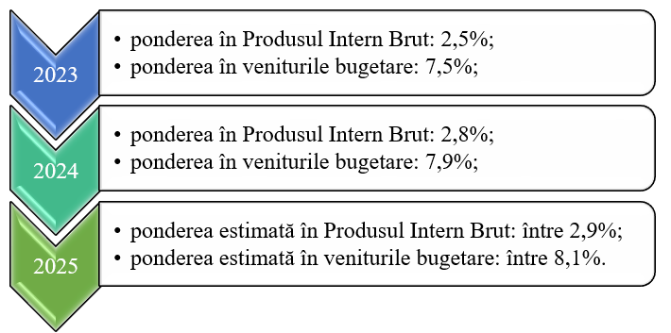

*Figure 1.* **Evolution of the Share of Income Tax in Gross Domestic Product and Budget Revenues (2023-2025)**

*Sursa:* own processing based on data published by the Ministry of Finance and Eurostat

A slightly upward trend can be observed, both in relation to GDP and as a share of total budget revenues, as illustrated in Figure 1. Although this evolution is positive, it continues to highlight the structural vulnerabilities of Romania’s fiscal system. The relatively low share of income tax in GDP and budget revenues, compared to the European average, reflects a fiscal regime characterized by low nominal tax rates, a budget structure dominated by social contributions, and ongoing challenges in revenue collection efficiency. Thus, despite the progress recorded during the 2023–2025 period, Romania continues to face a significant gap compared to European fiscal standards, underlining the need for further reforms to broaden the tax base and improve administrative performance. In this context of fiscal consolidation, a significant increase in net budget revenues collected by the National Agency for Fiscal Administration (ANAF) is also noted. In the first five months of 2024, ANAF collected budget revenues totaling 175.19 billion lei, marking a 17.8% increase compared to the same period in 2023, when revenues amounted to 148.67 billion lei. This positive development reflects improved efficiency in tax administration and the success of measures adopted to expand the tax base and enhance voluntary compliance. Notably, income tax made a significant contribution to this upward trend, recording an annual growth of over 25% in the last quarter of 2024. According to the Fiscal Statistical Bulletin no. 4/2024 published by ANAF, income tax represented a substantial component of budget revenues in Q4 2024. During this period, income tax revenues amounted to 13,313.6 million lei, a 25.7% increase compared to the same quarter of the previous year. This growth reflects both improved tax compliance and the effectiveness of ANAF’s digitalization efforts. Individual taxpayers, including employees and the self-employed, were the primary contributors to this tax. Additionally, the number of active registered taxpayers as of December 31, 2024, increased, indicating an expansion of the tax base. This evolution underscores the importance of income tax within the structure of budget revenues and highlights the effectiveness of the fiscal measures adopted to improve collection.

1. **Result**

The objective of the case study was to assess the efficiency and fiscal impact of the taxation regime applied to individuals, through a comparative analysis of data from 2023 and 2024, with projections for 2025. The primary data source was the budget execution published by the Ministry of Finance, supplemented by reports and press releases from ANAF. The main dimensions analyzed in the study included: the total volume of revenues collected from income tax; their contribution to the Gross Domestic Product (GDP); distribution by income sources—salaries, rental income, self-employment, pensions, investments—and the evolution of personal deductions and tax incentives.

**Taxation of income from salaries and similar salaries**

*Table 1.* **Fiscal and legislative context IT salary**

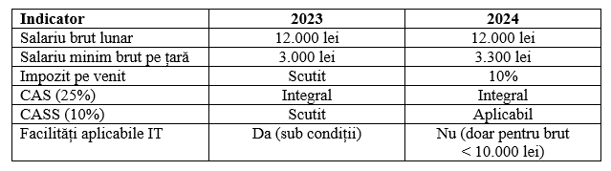

*Source:* own processing

*Table 2.* **Comparison between IT salary statements for 2023 and 2024**

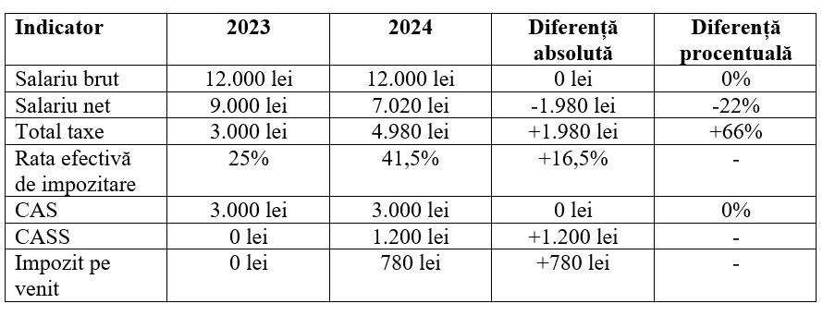

*Source:* own processing

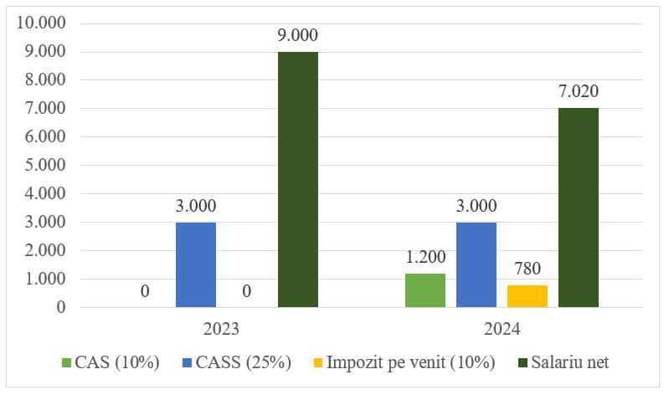

*Figure 2.* **Evolution of IT salary situations for 2023 and 2024**

*Source:* own processing

The case study, as shown in Tables 1 and 2 and Figure 2, highlights the significant impact of eliminating tax incentives for salary income in Romania. Employee-paid taxes increased by 66%, reducing the net salary by nearly 2,000 lei. The reintroduction of income tax and health insurance contributions (CASS) led to a rise in the effective tax rate from 25% to 41.5%, particularly affecting IT employees with incomes exceeding 10,000 lei. Although the measure aims to ensure fiscal equity across sectors, it may negatively impact the competitiveness of the IT industry.

**Taxation of income from self-employment**

*Table 3.* **Fiscal and legislative context IT norm**

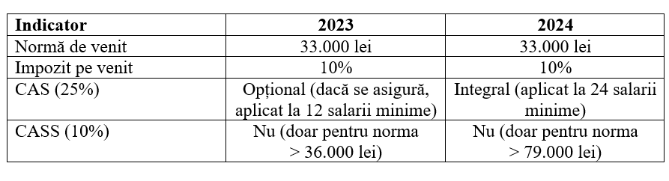

*Source:* own processing

*Table 4.* **Comparison between IT norms for 2023 and 2024**

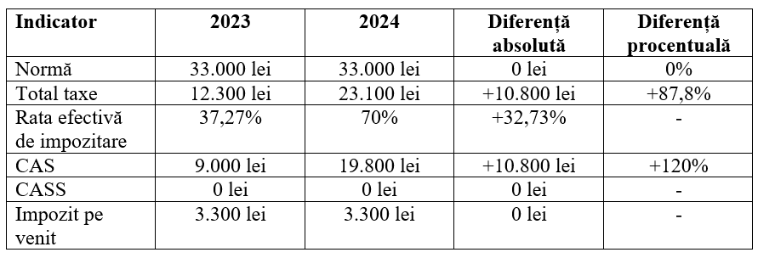

*Source:* own processing

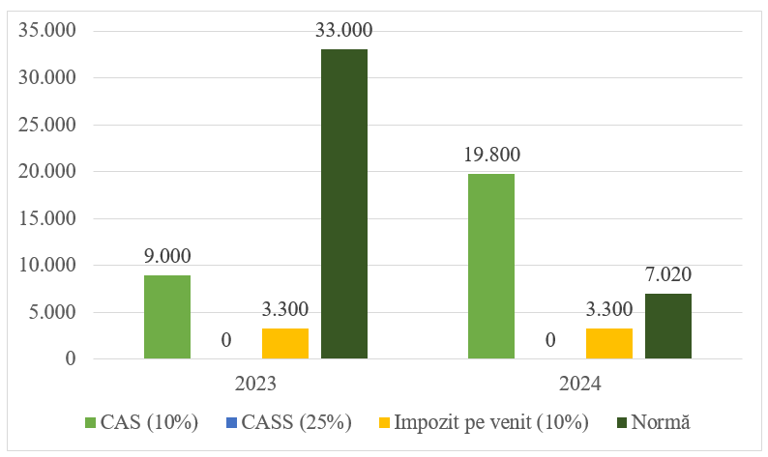

*Figure 3.* **Evolution of IT regulations for 2023 and 2024**

*Source:* own processing

The case study, presented in Tables 3 and 4 and Figure 3, shows a sharp increase in the tax burden for self-employment activities, with the effective tax rate rising from 37.37% in 2023 to around 70% in 2024. This significantly reduces net income, even though the income norm remained unchanged. The measure aims to ensure fiscal balance and reduce tax evasion, but without adjusting the income norms, it could seriously affect the viability of self-employment activities.

**Taxation of income from the transfer of use of goods**

*Table 5.* **Comparison of calculations of transfer of use of goods for 2023 and 2024**

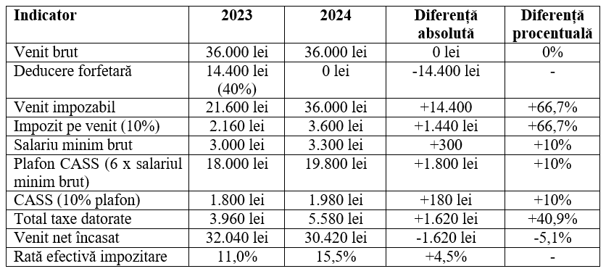

*Source:* own processing

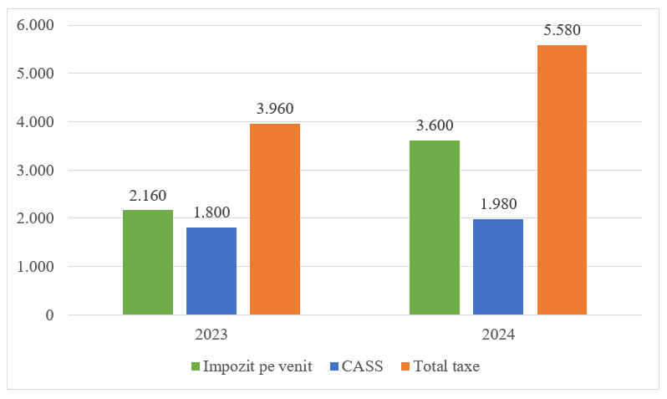

*Figure 4.* **Evolution of income from the transfer of use of goods for 2023 and 2024**

*Source:* own processing

The case study, based on Table 5 and Figure 4, highlights a significant increase in the tax burden on rental income, leading to a decrease in net income despite a constant gross income. The additional tax burden exceeds 1,600 lei per year. The measures aim to eliminate preferential treatment and broaden the tax base, but they may become burdensome for taxpayers, especially in the absence of a proportional increase in income.

**Taxation of investment income**

*Table 6.* **Comparison of investment calculations for 2023 and 2024**

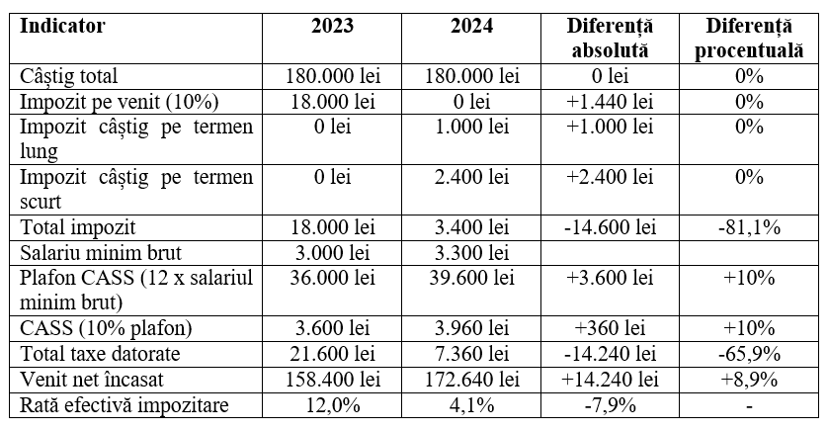

*Source:* own processing

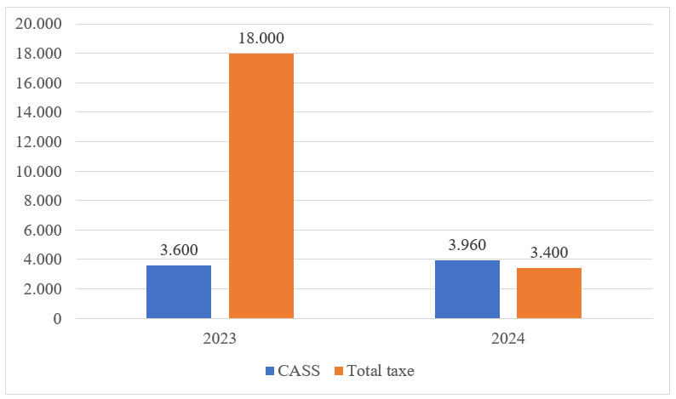

*Figure 5.* **Evolution of investment income situations for 2023 and 2024**

*Source:* own processing

The case study, presented in Table 6 and Figure 5, shows a significant reduction in the tax burden on investment income, with the effective tax rate decreasing by nearly 8 percentage points. This increases the net return for investors, reflecting a fiscal policy aimed at aligning with European standards and stimulating Romania’s capital market.

**Taxation of pension income**

*Table 7.* **Comparison of pension calculations for 2023 and 2024**

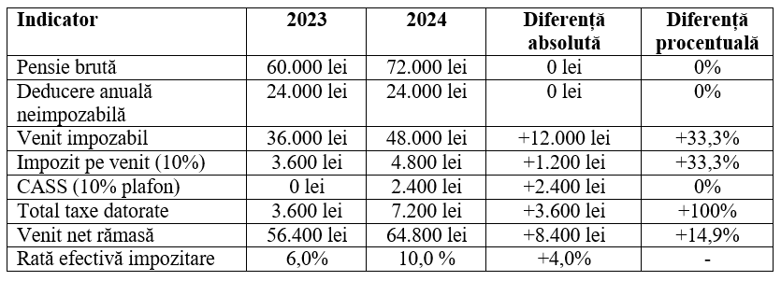

*Source:* own processing

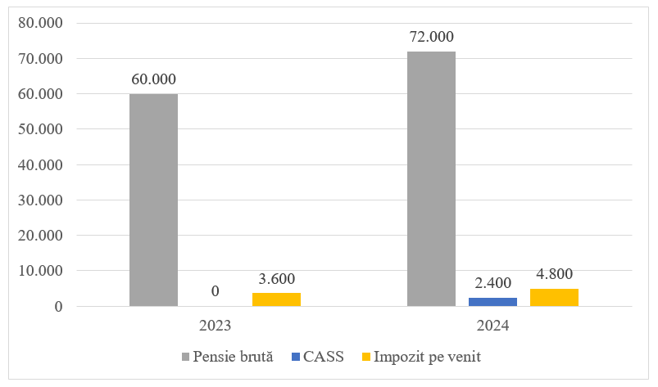

*Figure 6.* **Evolution of pension income situations for 2023 and 2024**

*Source:* own processing

The case study, based on Table 7 and Figure 6, shows an increase in the tax burden for pensions exceeding the threshold, following the introduction of health insurance contributions (CASS). However, net income rose by approximately 15% compared to 2023, due to the increase in gross pension amounts. This evolution reflects the delicate balance between fiscal consolidation and preserving pensioners’ purchasing power.

**Taxation of income from agricultural, forestry and fishing activities**

*Table 8.* **Comparison of agricultural activity calculations for 2023 and 2024**

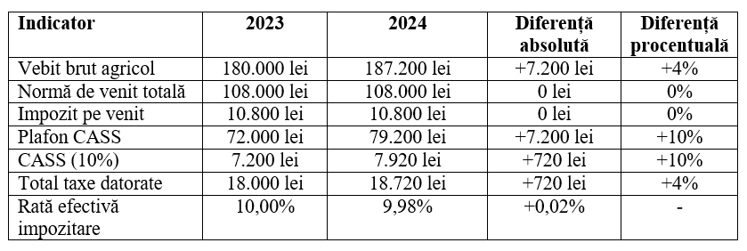

*Source:* own processing

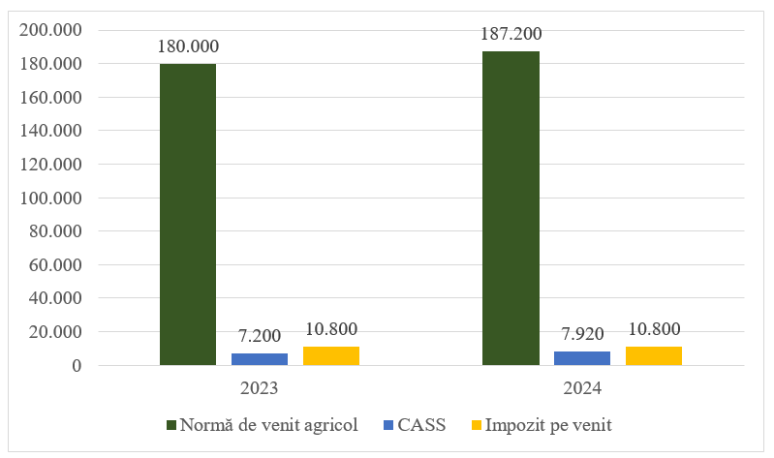

*Figure 7.* **Evolution of agricultural income situations for 2023 and 2024**

*Source:* own processing

The case study, based on Table 8 and Figure 7, shows that the income tax on agricultural revenues remains stable, as it is calculated using fixed norms. However, the increase in the minimum wage led to a 720 lei rise in CASS contributions in 2024, raising the total tax burden by 20%. Despite this, the effective tax rate slightly decreased, potentially encouraging investment and expansion of activity.

**Taxation of income from prizes and gambling**

*Table 9.* **Comparison of prize and glambling calculations for 2023 and 2024**

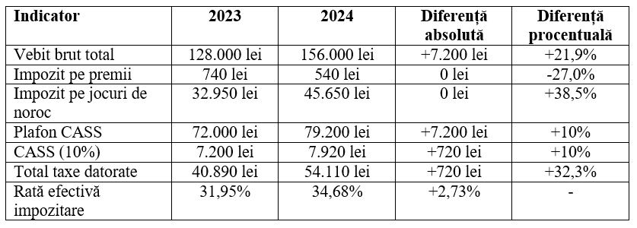

*Source:* own processing

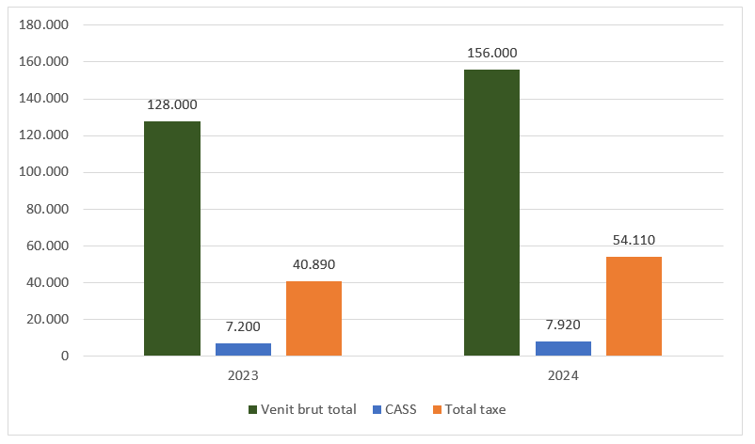

*Figure 8.* **Evolution of prize and glambling income situations for 2023 and 2024**

*Source:* own processing

The case study, based on Table 9 and Figure 8, shows that although income from prizes and gambling increased by 21.9%, taxes rose by over 32% due to higher tax rates introduced in 2024. Large gambling winnings are now significantly more heavily taxed, while prizes are subject to a more lenient regime. The application of CASS up to the threshold of 24 minimum wages limits the impact on very high incomes but still contributes to the overall increase in the tax burden.

**Taxation of income from other sources**

*Table 10.* **Comparison of calculations of other sources from 2023 and 2024**

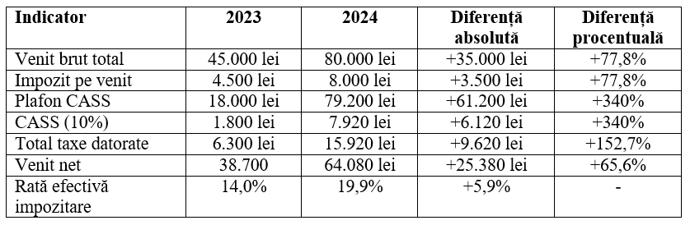

*Source:* own processing

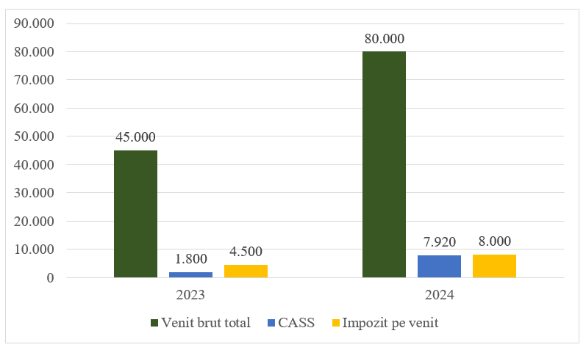

*Figure 9.* **Evolution of income situations from other sources for 2023 and 2024**

*Source:* own processing

The case study, based on Table 10 and Figure 9, shows that although gross income from other sources increased by 77.8%, taxes doubled in 2024 due to the application of the CASS cap at 24 minimum wages. The 10% income tax rate remained unchanged, with the increase in taxation stemming mainly from CASS. The effective tax rate rose by nearly 6 percentage points, highlighting a clear trend toward stricter taxation of occasional income.

## Conclusions

The income tax on individuals remains a key component of Romania’s fiscal system, contributing significantly to the public budget. The analysis of the 2023–2025 period shows a slight increase in revenues collected, supported by tax reforms, digitalization, and salary growth. However, the case studies reveal an unequal fiscal impact across different income categories.

For employees and self-employed individuals, the elimination of tax incentives and increased contributions have resulted in a much heavier tax burden, affecting disposable income and competitiveness in certain sectors, such as IT. For passive income (rent, prizes, other sources), the application of the CASS cap and higher tax rates have significantly increased taxation, contradicting the perception of low fiscal pressure. In contrast, investment income has benefited from tax relief, while agricultural income taxation has remained relatively stable. These differences highlight the need for a more balanced system, with clear rules and proportional tax treatment.

In conclusion, the current system requires structural adjustments to ensure equity across income types, maintain fiscal sustainability, and support economic development without discouraging active taxpayers.

# Bibliography

|  |  |
| --- | --- |
| [1] | P. Adriana Florina, P. Mirela and C. Radu, Fiscalitate, București: Editura CECCAR, 2025. |
| [2] | B. Corina, "The contribution of perfonal income tax to the formation of public financial resources," 2024. |
| [3] | A. N. A. Fiscală, 2024. [Online]. Available: https://www.anaf.ro. [Accessed 20 mai 2025]. |
| [4] | M. Tatiana, C. Emilia, Ț. Luciana, T. Roxana, P. Alice Ileana, C. Delia, A. Gyorgy, S. Andreea, B. Iulian and M. Emilian, Finanțe publice, București: Editura Universală, 2008. |
| [5] | I. N. Statistică, "Buletin statistic trimestrial," 2024. [Online]. Available: https://insse.ro. [Accessed 25 mai 2025]. |
| [6] | T. A, "Analiza reglementării veniturilor impozabile ale persoanelor fizice," 2024. |
| [7] | Eugen Nicolăescu and C. Sorin Adrian, Fiscalitate, București: Editura Pro Universitaria, 2018. |
| [8] | M. Simona-Gabriela, Coordonare fiscală. Suport de curs, Cluj-Napoca, 2020. |
| [9] | P. C. M., "Aspecte privind impozitarea veniturilor persoanelor fizice.," Arad, 2011. |
| [10] | V. Roman and L. Liliana, "Aspecte ale impozitului pe venit al subiecților ce desfășoară activități independente," in *International Scientific Conference on Accounting*, 2024. |