# Sculptify – A Comprehensive Meal and Exercise Planning Application for Personalized Health Management

miriam-paula, romaniuc

Universitatea Tehnică din Cluj-Napoca

Facultatea de Științe

Specializarea: Informatică

Coordonator științific:

Lect.univ.dr. Hajdu-Macelaru Mara

Email: miriamromaniuc@gmail.com

**Abstract**

This article introduces Sculptify, an innovative web application that streamlines the integration of healthy habits into daily life. With tailored training programs and meal plans, it caters to a diverse user base ranging from beginners to fitness enthusiasts with existing routines. Users can choose from predefined options, seek professional advice, or customize their plans. Focused on simplifying the complex landscape of personal wellness, Sculptify eliminates confusion and contradiction, providing a comprehensive and accessible platform for sustainable lifestyle changes. The app equips users with the knowledge and tools necessary for a permanent shift in their approach to health. Additionally, Sculptify serves as a client-management platform for nutritionists and trainers, facilitating a seamless connection between professionals and their clients.

**Keywords:** Digital Health Solutions, Personalized Nutrition, Workout Planner, User-Centric Design, Nutritional Guidance



## Introduction

In today's fast-paced world, prioritizing a healthy lifestyle can often take a backseat. However, addressing this challenge head-on is the innovative web application "Sculptify." This groundbreaking platform seamlessly integrates healthy habits into daily routines, revolutionizing the approach to wellness and fitness. This article will delve into Sculptify's core functionalities, with a particular focus on its unique features such as personalized meal and workout planners, step-by-step cooking guides, and live workout tracking. What truly sets Sculptify apart is its algorithm for creating meal and workout plans, meticulously crafted based on the latest and most significant research in the field. By leveraging expert knowledge and cutting-edge research, Sculptify empowers users with the tools and insights needed to enact lasting changes in their health perspectives.

By bridging the gap between expert knowledge and everyday practice, Sculptify positions itself as a beacon for those aspiring to improve their health but are often lost in the maze of conflicting information and hectic schedules. Additionally, the platform offers a unique client-management system for nutritionists and trainers to directly create personalized plans for their clients.

## Preliminary Section

From meal and workout planners to intuitive tracking systems, the app harnesses the power of technology not as an end but as a means to facilitate a healthier, more informed lifestyle. This technological aspect is not only about functionality but also about creating a platform that is engaging, motivating, and educational.

## Theoretical Aspects

Despite the primary focus of this work being the analysis of the application itself, covering all its technical aspects relevant to the field of information technology, it's essential to emphasize the importance of a strict methodology for creating dietary and workout plans. This chapter will detail the process for developing these plans, explaining the reasoning behind each decision to ensure accuracy and rigor in this crucial aspect of the application.

### Nutritional Approach

Since the app focuses on weight loss/gain goals, we'll use the ratio of caloric intake to total energy expended throughout the day. Although many factors play a role, we'll focus on the basic rules of metabolic processes, addressing other factors like macronutrient and micronutrient intake quality in a future section. For the calculation of the TDEE (Total Daily Energy Expenditure) of each user, we’ve carefully selected the equation that is known to best estimate the BMR (Basal Metabolic Rate) that will be then multiplied by a Personal Activity Level (PAL) [1] [2].

For selecting the appropriate formula, we consulted a meta-analysis that highlights the most accurate equations by comparing the results of 29 studies involving a total of 1430 participants (822 females, 608 males) and 100 different equations for estimating Resting Metabolic Rate (RMR). Only 11 equations met the criteria for accuracy to be included in the meta-analysis. The meta-analysis revealed that predicted RMR values did not significantly differ from measured values for five equations (Cunningham (1980), Harris-Benedict (1918), Cunningham (1991), De Lorenzo, Ten-Haaf), while all others significantly underestimated or overestimated RMR (p<0.05) (Mifflin-St. Jeor, Owen, FAO/WHO/UNU, Nelson, Koehler). Among these five equations, substantial heterogeneity was observed for all (p<0.05, I² interval: 80–93%), except for Ten-Haaf (p=0.48, I²=0%). Significant differences between subgroups were observed for some, but not all equations, based on sex, athlete status, fasting status before RMR testing, and RMR measurement methodology. Nine equations met the criteria for meta-analysis precision. Among these nine equations, Ten-Haaf was considered the most precise, predicting that 80.2% of participants would fall within a margin of ±10% from measured values, with all others ranging between 40.7 and 63.7% [3].

Thus, the chosen equation for BMR is:

$$BMR=11,936*W+587,728*H-8,129*A+191,027*S\left(M:1, F:0\right)+29,279$$

Where,

W = weight in kilograms

H = height in meters

V = age in years

S = sex (male or female)

Whenever there will be access to the Body Fat Percentage of the individual, a slightly more precise equation will be used, that takes into consideration the fat-free mass:

$$BMR=22,771*MLG+484,264$$

Where,

FFM = fat-free mass in kilograms (Total weight – Total weight * body fat percentage) [4].

Now, to calculate TDEE, we only need to determine the multiplier factor, PAL [1]. Generally, activity levels are divided into 5 categories: Sedentary lifestyle: PAL = 1.2 (For individuals with very little or no physical activity throughout the day, such as desk jobs, reading, or watching TV. Minimal movement includes basic activities like short walks or light household chores.); Low active: PAL = 1.37 (For individuals engaging in light exercises or sports 1-3 days per week, in addition to sedentary activities. This may include brisk walking, light cycling, yoga, or other low-demanding exercises.); Moderately active: PAL = 1.55 (For those performing moderate exercises 3-5 days per week, such as jogging, swimming, brisk walking, moderate cycling, dancing, or other activities that moderately raise heart rate.); Very active: PAL = 1.72 (For individuals engaging in intense exercises or sports 6-7 days per week, like running, intense cycling, competitive team sports, intense strength training, or other highly demanding exercises maintaining a high heart rate for extended periods.); Extremely active: PAL = 1.9 (Applies to individuals with exceptionally high levels of physical activity, such as elite athletes, construction workers, or those with very physically demanding jobs. It includes very intense exercises, long training sessions, or heavy physical work performed regularly.)

For creating a calorie deficit leading to weight loss, the aim is to sustainably lose the greatest amount of adipose tissue while preserving muscle mass, vital for overall health [5]. It's known that 1 kg of adipose tissue contains 7,700 kcal [6]. For obese individuals, a deficit of around 500-750 kcal/day or more is often recommended [7] [8]. However, for those not classified as obese, a more cautious approach is necessary due to metabolic adaptation during weight loss [9] [10]. A moderate calorie deficit results in better body composition, preserving muscle mass.

There's evidence showing significant reductions in waist and hip circumferences in groups with slower weight loss compared to rapid weight loss. Additionally, a slow weight loss group exhibited significant reductions in body fat mass and percentages compared to a rapid weight loss group [11]. Moreover, there was a significant decrease in muscle mass, total body water, and basal metabolic rate in the rapid weight loss group compared to the slow weight loss group. Therefore, we set the upper limit for a sustainable calorie deficit at 25% of Total Daily Energy Expenditure (TDEE) [12].

Similarly, for users aiming to increase their weight, the goal is to maintain a healthy body composition, including an appropriate percentage of muscle mass. Unlike adipose tissue, muscle mass contains only 1600 kcal/kg. However, this doesn't mean that a surplus of 1600 kcal will lead to the deposition of one kilogram of muscle mass, as it doesn't account for the calories needed for muscle tissue formation. Taking this into consideration, the calorie requirement for creating one kilogram of muscle mass amounts to 5700-6300 kcal [13]. Nevertheless, the process is highly complex and comprehensive, thus a daily surplus of 350-500 kcal is recommended, with adjustments made based on observed results [14].

For users seeking overall quality of life improvements without altering their weight or body composition, recommended values are 45%-65% of calories from carbohydrates, 20%-35% from fats, and 10%-35% from proteins [15].Regarding protein intake needed for optimal health, the minimum recommended amount has remained unchanged for the past 70 years at 0.8 grams of protein per kilogram [16].

When aiming for weight loss, new factors come into play. While we understand that weight loss occurs solely through a caloric deficit and that macronutrient proportions don't affect the amount of weight lost [17] [18], they have numerous other effects, including satiety levels, muscle preservation, adherence to the diet, and fat loss [19] [20]. Given these considerations, special attention is given to protein intake [21]. Significant benefits have been observed in consuming higher amounts of protein during exercise-assisted weight loss processes, such as maintaining more muscle tissue and significantly greater fat loss solely by adjusting protein intake during a deficit period [22] [23]. Therefore, recommendations range from 1.6 to 2.4 grams of protein per kilogram, with the lower limit for those not following an exercise program [24] [25] [26]. For users aiming to gain muscle mass and thus operating on a caloric surplus, recommendations are similar, with slightly lower protein needs ranging from 1.4 to 1.8 grams per kilogram [23].

### Training Approach

Within these objectives, users will be able to set two goals: increasing strength itself and increasing strength accompanied by hypertrophy, as the training structure will vary depending on these [27] [28]. For those aiming for hypertrophy, specific muscle groups or muscles to be targeted for growth will be identified, and the plan will be optimized accordingly. Any muscle in this category will be trained with a minimum of 12 sets per week and a maximum of 28, depending on the selected muscle quantity in the program. Each exercise will involve 3-6 sets of 6-12 repetitions at an intensity of 60-80% of 1RM, occasionally including sets to failure to maximize muscle growth without unnecessary exhaustion [29] [30] [31] [27]. The key driver of muscle growth is the gradual increase in training volume (whether through sets, repetitions, or weight), not exhaustion itself. Furthermore, the core exercises set for personalized muscle growth will remain constant throughout the objective to ensure progress clarity and resource efficiency [32]. Regarding exercise frequency for hypertrophy, this will be based on user preferences as it doesn't impact final outcomes, considering only the necessary rest between workouts focused on the same muscle group [33]. Exercise tempo will be slow on the eccentric part of the movement and rapid on the concentric [34]. Recommended rest intervals will be around 120 seconds between each set [35]. Exercises involving multiple joints will be prioritized over those involving single joints, as they activate more muscles [36].

## Primary Functionalities

### Customized Meal Planning

This functionality allows users to effortlessly navigate the complexities of nutrition. Whether users prefer selecting from pre-designed meal plans, crafting their own, or obtaining a personalized plan through a quiz, Sculptify caters to a range of dietary preferences and needs. For those seeking expert advice, the option to have a meal plan crafted by a nutritionist or trainer enhances the bespoke nature of the service. This feature simplifies the process of eating healthily while ensuring that each plan is balanced, appealing, and aligned with individual health goals.

Personalized meal plans are meticulously designed based on each user's unique metrics, lifestyle, and objectives. The process begins by gathering essential data such as age, weight, height, gender, activity level, and health goals, which are then used to estimate the Basal Metabolic Rate (BMR) and Total Daily Energy Expenditure (TDEE). These calculations define the individual's daily caloric intake requirements to achieve their objectives, with macronutrient distribution tailored accordingly.

Meal plans offer flexibility with two to six meals per day, depending on the user's preferred frequency and portion sizes. Meanwhile, a recommendation system runs in the background, refining meal suggestions based on prior preferences and interactions. This ensures that each user's meal plan evolves in taste, portion size, and recipe choices, providing satisfying and nutritious options aligned with their unique goals. The recommendation system and tailored meal planning work in harmony to deliver a seamless, enjoyable nutrition experience that is always personalized.

Image 3. Daily Resume Interface. Autor: Romaniuc Miriam

Image 2. Weekly Meal Plan Resume Interface. Autor: Romaniuc Miriam

Image 1. Daily Meal Pla. Autor: Romaniuc Miriam

Image 4. Meal Plan Creation Interface. Autor: Romaniuc Miriam

### Comprehensive Workout Planning

Parallel to its meal planning feature, Sculptify will offer an extensive workout planner. Users can choose from pre-determined routines, create their own, or have a tailored plan developed by a trainer or through a specialized algorithm that analyzes personal fitness needs. This approach acknowledges the diversity in fitness levels and goals, offering a customizable and scalable solution. Whether the user is a beginner or an experienced athlete, the workout planner is designed to adapt and evolve in response to their changing fitness journey.

Every aspect of the workout planner is grounded in science to ensure effective and safe training. Users can select from two to seven workouts per week, with the plan tailored to focus on specific muscle groups or broader objectives like reducing overall adipose tissue, improving endurance, or enhancing strength. The program adapts accordingly, offering a mix of strength training, muscle hypertrophy, and cardio exercises. Each session is structured with clear targets, and users can participate in live workouts where they track progress toward these targets.

The system is dynamic and responsive to individual performance, adjusting if targets are not met or goals evolve. Detailed graphs allow users to monitor progress for each exercise, visualize muscle size improvements, and stay motivated as they see tangible results. Cardio training is also integrated, with users able to choose their preferred style and intensity, ensuring a well-rounded and enjoyable fitness plan. With personalized plans based on muscle growth, performance goals, or endurance, Sculptify's workout planner offers an adaptable, data-driven path to fitness success.

Image 8. Exercise Selection Interface. Autor: Romaniuc Miriam

Image 7. Daily Workout Interface. Autor: Romaniuc Miriam

Image 6. Workout Plan Weekly Resume Interface. Autor: Romaniuc Miriam

Image 5. Workout Plan Selection Interface. Autor: Romaniuc Miriam

### Synchronization with Meal-Planning

The Workout Planner is not an isolated feature; it'll be integrated with the app's meal planning function. This integration ensures that a user's nutritional intake aligns with their workout regimen, optimizing overall health and fitness results.

### Interactive Step-by-Step Cooking Guidance

Understanding that following a meal plan can be daunting, Sculptify disposes an interactive, user-friendly interface for cooking. Each recipe in the meal plan comes with detailed, step-by-step instructions, ensuring users can easily follow along without the hassle of searching for information. This feature is particularly beneficial for those new to cooking or trying unfamiliar recipes, making the process of adhering to the meal plan not just simpler but also more enjoyable.

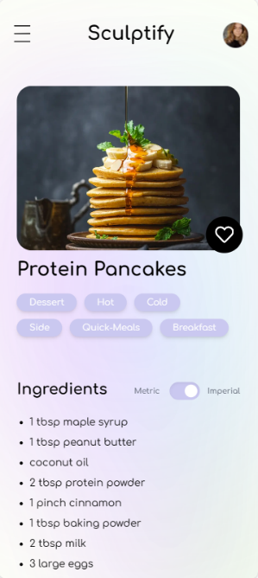

Image 10: All Recipes. Autor: Romaniuc Miriam

Image 9. Recipe Interface. Autor: Romaniuc Miriam

Image 11. Step By Step Cooking. Autor: Romaniuc Miriam

### Live Workout Tracking

Sculptify enhances the workout experience with its live tracking feature. Once a user will start a workout from the app, they can monitor their progress in real time. This includes tracking sets, repetitions, weights used in weightlifting exercises, and other useful metrics for various exercises. Each exercise is accompanied by a video demonstration and tips for correct execution, providing a comprehensive guide to ensure effective and safe workouts.

Image 14. Live Workout Tracking. Autor: Romaniuc Miriam

Image 13. Live Workout Tracking. Autor: Romaniuc Miriam

Image 12. Daily Workout Preview. Autor: Romaniuc Miriam

### Useful insights for users and trainers

A key feature of Sculptify will be the provision of useful insights for both users and trainers. Professionals assigned to a new client have access to all relevant information, including Basal Metabolic Rate (BMR), Total Daily Energy Expenditure (TDEE), activity levels, body fat percentage, and more. This data is presented alongside graphical representations of the correlation between caloric intake and weight or body fat changes. Additionally, clients have access to this information, allowing them to track their own progress and understand the impact of their meal plans and workouts on their health.

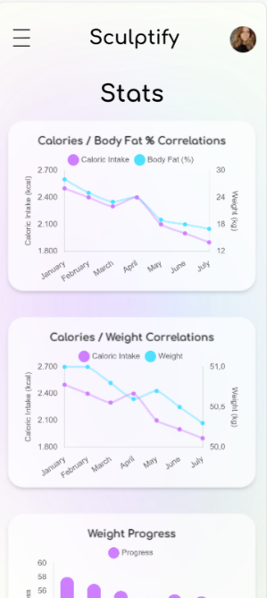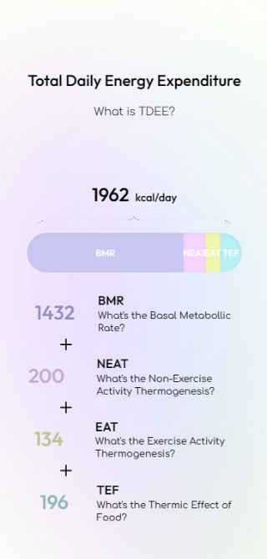

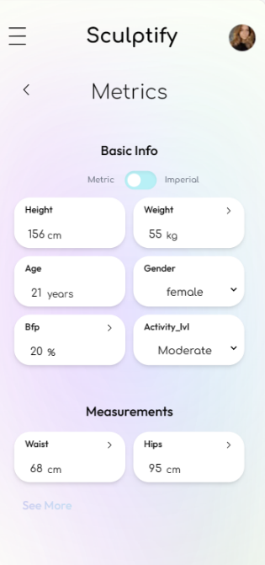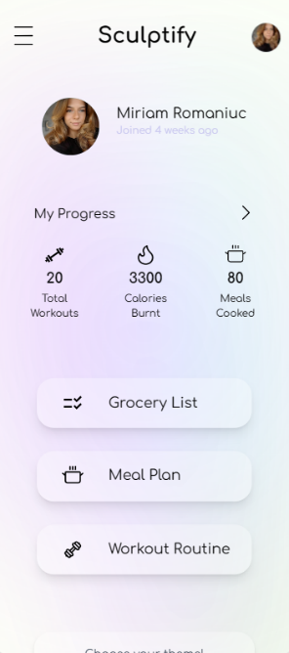

Images 14, 15, 16, 17, 18. User Metrics. Autor: Romaniuc Miriam

### Client Management Platform for Professionals

Sculptify isn't just for individual users; it also functions as a comprehensive client-management platform for nutritionists and trainers, enhancing their ability to deliver effective, personalized services. This feature allows professionals to access a wealth of relevant client data, including Basal Metabolic Rate (BMR), Total Daily Energy Expenditure (TDEE), activity levels, dietary preferences, and fitness goals. Armed with this data, nutritionists and trainers can develop meal and workout plans that are not only tailored to individual needs but also rooted in scientific principles and best practices.

The platform presents professionals with actionable insights into client health metrics and progress over time, facilitating precise adjustments to nutrition and workout regimens. Direct communication channels foster seamless interactions between professionals and their clients, allowing trainers to share feedback, progress updates, and motivational messages, thus enhancing accountability and results. The ability to customize plans based on unique client needs allows for a diverse range of programs, from weight loss and muscle gain to endurance improvement and overall wellness.

Managing multiple clients is simplified through an intuitive dashboard where trainers can track individual progress, review adherence to plans, and provide timely interventions. Sculptify's built-in discovery feature connects clients with nutritionists or trainers that best match their specific goals and preferences, ensuring mutually beneficial partnerships. Additionally, trainers and nutritionists can collaborate on creating holistic health plans that align diet and exercise for optimal results, offering an integrated approach that increases the likelihood of client success. This synergy ultimately empowers professionals to deliver an elevated, data-driven service, improving the efficiency and effectiveness of their client management and ensuring sustainable, personalized health outcomes.

## Technologies used

The app leverages a powerful combination of modern web technologies to deliver a seamless and intuitive user experience. The development stack includes Next.js, React, Tailwind CSS, and MySQL, each playing a crucial role in its functionality and design.

### Next.js

Next.js serves as the backbone of Sculptify's web application, offering a robust platform for server-side rendering (SSR) and static site generation (SSG). These features are instrumental in improving page load times and enhancing SEO. Next.js's automatic code splitting optimizes the application's performance by loading only the necessary JavaScript for each page. Its file-system-based routing system simplifies navigation within the app, and the built-in API routes enable seamless integration of backend functionalities. The framework's support for hybrid pages allows Sculptify to optimize rendering strategies based on content needs, blending static generation with server-side rendering where beneficial.

### React

React forms the core of Sculptify’s user interface development, particularly for its dynamic and interactive components. The library's component-based architecture promotes encapsulated and reusable code, enhancing maintainability. React’s Virtual DOM implementation ensures minimal and efficient DOM manipulation, leading to superior performance. The declarative nature of React makes the UI more readable and easier to debug. Additionally, React's extensive ecosystem provides a wealth of libraries and tools, allowing for flexible and speedy development of complex features.

### Tailwind CSS

Tailwind CSS is employed for styling Sculptify, adopting a utility-first approach to CSS that facilitates rapid and responsive design. This approach allows developers to construct designs directly within HTML markup, reducing the need for bespoke CSS and improving design consistency across the application. Tailwind’s built-in responsive design utilities enable easy crafting of interfaces that adapt seamlessly to different screen sizes. Its high customizability ensures that the specific design needs of Sculptify are met, while integration with tools like PurgeCSS guarantees that the final build is lightweight and optimized for performance.

### MongoDB

The choice of MongoDB as the database management system is pivotal for Sculptify. The app handles a diverse range of user data, including profiles, health metrics, meal plans, workout routines, and progress tracking, which can be complex and varied. MongoDB, as a flexible NoSQL database, excels at managing such diverse data structures, allowing for efficient storage, retrieval, and updating. Its schema-less design supports rapid iterations of data models, making it suitable for handling evolving data needs while ensuring data integrity and security.

MongoDB's flexible document-oriented structure facilitates efficient data relationships and queries, providing personalized experiences within the app. For instance, it can correlate user health metrics with tailored meal and workout plans, monitor progress over time, and grant trainers access to client information for personalized coaching. Its scalability is also crucial, ensuring that as Sculptify expands its user base, the database can effortlessly handle the increasing volume of user data.

## Conclusion

In closing, Sculptify represents a promising step towards a future where health and wellness are made accessible and convenient. While the app is still in its conceptual stage, it holds the potential to transform the way we approach our well-being. By harnessing user engagement data and the power of technology, Sculptify envisions a future where personalized health and fitness are within reach for everyone. As users will embrace this innovative tool, it has the potential to accumulate a wealth of data, not only regarding their progress but also their behavioral patterns and levels of engagement throughout the application. One of the most thrilling possibilities on the horizon is the integration of machine learning models, driven by the treasure trove of user engagement data Sculptify can amass. This data is a window into the hearts and minds of users, revealing not just their fitness achievements but also their motivations, preferences, and the factors that keep them engaged.

As we look forward to the app's development, we anticipate a digital health companion that empowers users with knowledge and offers tailored support, ultimately making the journey to a healthier lifestyle more achievable and enjoyable.

# Bibliografie

|  |  |
| --- | --- |
| [1] | J. Park, „Using physical activity levels to estimate energy requirements of female athletes,” *J Exerc Nutrition Biochem,* vol. 23, nr. 4, 2019. |
| [2] | H. a. M. D. F. a. N. B. ș. C. o. t. D. R. I. f. E. E. a. M. National Academies of Sciences, „Development of Prediction Equations for Estimated Energy Requirements,” *Dietary Reference Intakes for Energy., Washington (DC), National Academies Press (US),* 2023. |
| [3] | C. A. C. K. H. Jack Eoin Rua O'Neill, „Accuracy of Resting Metabolic Rate Prediction Equations in Athletes: A Systematic Review with Meta-analysis,” *Sports Medicine,* vol. 53, pp. 2373-2398, 2023. |
| [4] | P. J. M. W. Twan ten Haaf, „Resting energy expenditure prediction in recreational athletes of 18-35 years: confirmation of Cunningham equation and an improved weight-based alternative,” *PLoS One,* vol. 9, nr. 10, 2014. |
| [5] | M. H. P. T. L.-I. K. H. J. J. Kristoffer Jensen Kolnes, „Effect of Exercise Training on Fat Loss—Energetic Perspectives and the Role of Improved Adipose Tissue Function and Body Fat Distribution,” *Frontiers in Physiology,* vol. 12, 2021. |
| [6] | M. H. P. T. L.-I. K. H. J. J. Kristoffer Jensen Kolnes, „Effect of Exercise Training on Fat Loss—Energetic Perspectives and the Role of Improved Adipose Tissue Function and Body Fat Distribution,” *Frontiers in Physiology,* vol. 12, 2021. |
| [7] | 1. W.-Y. L. S. S. K. J.-H. K. J.-H. K. K. K. K. B.-Y. K. Y.-H. K. W.-J. K. E. M. K. H. S. K. Y.-A. S. H.-J. S. K. R. L. K. Y. L. S. Y. L. S. Mi Hae Seo, „2018 Korean Society for the Study of Obesity Guideline for the Management of Obesity in Korea,” *Journal of Obesity and Metabollic Syndrom,* vol. 28, nr. 1, 2019. |
| [8] | Harvey-Berino, „Calorie restriction is more effective for obesity treatment than dietary fat restriction,” *ANNALS OF BEHAVIORAL MEDICINE,* vol. 21, nr. 1, 1999. |
| [9] | S. S.-P. N. A. J.-P. D. C. B. A. T. Eric Doucet, „Evidence for the existence of adaptive thermogenesis during weight loss,” *British Journal of Nutrition,* vol. 85, 2001. |
| [10] | J. L. K. G. L. a. É. D. Alexander Schwartz, „Greater Than Predicted Decrease in Resting Energy Expenditure and Weight Loss: Results From a Systematic Review,” *Obesity,* vol. 20, nr. 11, pp. 2155-2321, 2012. |
| [11] | M. G. N. L.-D. Damoon Ashtary-Larky, „Rapid Weight Loss vs. Slow Weight Loss: Which is More Effective on,” *Int J Endocrinol Metab,* vol. 15, nr. 3, 2017. |
| [12] | L. M. R. a. E. Ravussin, „Caloric Restriction in Humans: Impact on Physiological, Psychological, and Behavioral Outcomes,” *Antioxid Redox Signal,* vol. 14, nr. 2, 2011. |
| [13] | K. D. Hall, „What is the Required Energy Deficit per unit Weight Loss?,” *Int J Obes (Lond),* vol. 32, nr. 2, 2008. |
| [14] | B. P. D. D. J. M. E. R. H. G. S. a. J. I. Gary John Slater, „Is an Energy Surplus Required to Maximize Skeletal Muscle Hypertrophy Associated With Resistance Training,” *Frontiers in Nutrition,* vol. 6, 2019. |
| [15] | B. J. Venn, „Macronutrients and Human Health for the 21st Century,” *Nutrients,* vol. 12, nr. 8, 2020. |
| [16] | A. M. C. G. K. I.-Y. K. Robert R Wolfe, „Optimizing Protein Intake in Adults: Interpretation and Application of the Recommended Dietary Allowance Compared with the Acceptable Macronutrient Distribution Range,” *Advances in Nutrition.* |
| [17] | B. G. P. G. D. M. P. J. R. M. S. E. C. M. C. L. M. Laurance W. Kinsell M.D., „Calories do count,” *Metabolism,* vol. 13, nr. 3, 1963. |
| [18] | R. K. Scott Howell, „“Calories in, calories out” and macronutrient intake: the hope, hype, and science of calories,” *American Journal of Physiology,* vol. 313, nr. 5, 2017. |
| [19] | S. F. Pere Morell, „Revisiting the role of protein-induced satiation and satiety,” *Food Hydrocolloids,* vol. 68, pp. 199-210, 2016. |
| [20] | N. C. Y. a. B. M. Edda Cava, „Preserving Healthy Muscle during Weight Loss,” *Advances in Nutrition,* vol. 8, nr. 3, 2017. |
| [21] | L. J. M. P. M. C. M. N. G. D. B. Thomas P Wycherley, „Effects of energy-restricted high-protein, low-fat compared with standard-protein, low-fat diets: a meta-analysis of randomized controlled trials,” *Am J Clin Nutr,* vol. 96, nr. 6, 2012. |
| [22] | S. Y. O. C. J. M. M. C. D. Thomas M Longland, „Higher compared with lower dietary protein during an energy deficit combined with intense exercise promotes greater lean mass gain and fat mass loss: A randomized trial,” *American Journal of Clinical Nutrition,* vol. 103, nr. 3, 2016. |
| [23] | C. M. K. B. I. C. P. J. C. S. D. W. T. M. S. M. P. T. N. Z. A. A. F. S. M. A. A. E. S.-R. J. R. S. ,. P. J. A. M. J. O. L. W. T. C. D. W. Ralf Jäger, „International Society of Sports Nutrition Position Stand: protein and exercise,” *J Int Soc Sports Nutr,* 2017. |
| [24] | S. M. P. Amy J. Hector, „Protein Recommendations for Weight Loss in Elite Athletes: A Focus on Body Composition and Performance,” *International Journal of Sport Nutrition and Exercise Metabolism,* vol. 28, nr. 2, pp. 170-177, 2018. |
| [25] | S. M. Phillips, „Dietary protein requirements and adaptive advantages in athletes,” *British Journal of Nutrition,* vol. 108, nr. 52, 2012. |
| [26] | A. G. Kenneth Vitale, „Nutrition and Supplement Update for the Endurance Athlete: Review and Recommendations,” *Nutrients,* vol. 11, nr. 6, 2019. |
| [27] | M. W. G. W. a. A. G. Michal Krzysztofik, „Maximizing Muscle Hypertrophy: A Systematic Review of Advanced Resistance Training Techniques and Methods,” *Int J Environ Res Public Health,* vol. 16, nr. 24, 2019. |
| [28] | B. C. J. K. J. G. K. D. R. B. a. A. A. BRAD J. SCHOENFELD, „Resistance Training Volume Enhances Muscle Hypertrophy but Not Strength in Trained Men,” *Med Sci Sports Exerc,* vol. 51, nr. 1, 2019. |
| [29] | A. F. Vieira, D. Umpierre, J. L. Teodoro, S. C. Lisboa, B. M. Baroni, M. Izquierdo și E. L. Cadore, „Effects of Resistance Training Performed to Failure or Not to Failure on Muscle Strength, Hypertrophy, and Power Output: A Systematic Review With Meta-Analysis,” *Journal of Strength and Conditioning Research,* vol. 35, nr. 4, pp. 1165-1172, 2021. |
| [30] | B. J. S. ,. C. S.-B. ,. T. d. S. B. ,. A. Y. A. ,. H. B. ,. R. L. ,. V. T. ,. B. d. A. P. ,. E. L. T. Thiago Lasevicius, „Muscle Failure Promotes Greater Muscle Hypertrophy in Low-Load but Not in High-Load Resistance Training,” *J Strength Cond Res,* vol. 36, nr. 2, pp. 345-351, 2022. |
| [31] | „The Mechanisms of Muscle Hypertrophy and Their Application to Resistance Training,” *Journal of Strength and Conditioning Research,* vol. 24, pp. 2587-2872, 2010. |
| [32] | B. J. S. J. T.-U. J. S.-C. C. B.-F. Eneko Baz-Valle, „The effects of exercise variation in muscle thickness, maximal strength and motivation in resistance trained men,” *PLoS One,* vol. 14, nr. 12, 2019. |
| [33] | J. G. J. K. Brad Jon Schoenfeld, „How many times per week should a muscle be trained to maximize muscle hypertrophy? A systematic review and meta-analysis of studies examining the effects of resistance training frequency,” *J Sports Sci,* vol. 37, nr. 11, pp. 1286-1295, 2019. |
| [34] | M. W. ·. A. Z. J. J. Tufano, „The Infuence of Movement Tempo During Resistance Training,” *Sports Medicine,* vol. 51, pp. 1629-1650, 2011. |
| [35] | B. L. ,. P. M. ,. J. W. K. ,. B. J. S. Jozo Grgic, „The effects of short versus long inter-set rest intervals in resistance training on measures of muscle hypertrophy: A systematic review,” *Eur J Sport Sci,* vol. 17, nr. 3, pp. 983-993, 2017. |
| [36] | D. S. ,. V. C. ,. O. A. ,. A. P. ,. P. G. Matheus Barbalho, „The Effects of Resistance Exercise Selection on Muscle Size and Strength in Trained Women,” *Int J Sports Med,* vol. 42, nr. 4, pp. 371-376, 2021. |
| [37] | P. C. Pop, O. Matei, C. Sabo și A. Petrovan, „A two-level solution approach for solving the generalized minimum spanning tree problem,” *European Journal of Operational Research,* vol. 265, nr. 2, pp. 478-487, 2018. |