Automating a greenhouse using the Arduino platform

Mihály Konyicska
politehnica university Timișoara
Faculty of Electronics, Telecommunications and Information Technologies
Specialization: Biomedical Electronics
Email: mihai.konyicska@yahoo.com

Abstract
Automation of agricultural processes is an ever-evolving field, seeking to improve efficiency and sustainability in food production. This paper explores the use of the Arduino platform in automating a greenhouse, providing a practical and affordable solution for plant growers. By integrating temperature, humidity, light and soil moisture sensors, the Arduino platform enables constant monitoring of environmental conditions in greenhouses and automatic adjustment of parameters to optimize plant growth. Also, the automatic control of the irrigation system contributes to the efficient management of resources and the provision of an optimal environment for plant development. Implementing this solution offers significant advantages, including increased yield, reduced water, energy consumption and reduced risk of crop loss.
Keywords: Greenhouse, Arduino, UV, Ultrasounds.

Introduction
In the global context of climate change and the continuous increase in demand for food, efficiency and sustainability in agriculture are becoming increasingly important priorities. Automating agricultural processes is an essential way to optimize production and meet the increasingly complex challenges of the agricultural sector. In this regard, one of the emerging technologies that is attracting more and more attention is the use of the Arduino platform for greenhouse automation.
This paper explores the potential and benefits of automating a greenhouse using the Arduino platform, providing a detailed insight into how this technology can revolutionize traditional farming practices. By integrating environmental sensors and automated control systems, the Arduino platform enables constant monitoring and regulation of critical greenhouse environmental parameters such as temperature, humidity, light, and soil moisture.

Preliminary section
For the realization of this project, the following were used:
• Arduino IDE for writing codes in C/C++;
• Fritzing for making the electronic scheme of the system.

The technologies underlying the operation of the system are:
• The resistance of the sensor materials;
• UV light;
• Ultrasounds.

Ultraviolet (UV) light is electromagnetic radiation with wavelengths between 10 to 400 nanometers; it is longer than X-rays but shorter than visible light. Sunlight contains ultraviolet radiation, which makes up around 10% of all the electromagnetic radiation the Sun emits. In addition, electric arcs, Cherenkov radiation, and specialty lights like tanning lamps, black lights, and mercury-vapor lamps can produce it. The energy of ultraviolet photons is higher than that of visible light, ranging from roughly 3.1 to 12 electron volts, or roughly the lowest energy needed to ionize an atom. Long-wavelength UV light can produce chemical reactions and the fluorescence or glow of many materials, but it is not classified as an ionizing radiation since its photons do not have enough energy. UV radiation can interact with organic molecules to produce a variety of useful effects, including chemical and biological ones. These interactions don't always require heating; they might also include absorption or changing the energy states of molecules. UV light with a short wavelength is ionizing radiation. As a result, short-wave UV sterilizes surfaces it comes into touch with and destroys DNA [1].
Sound frequencies higher than 20 kilohertz are referred to as ultrasound. The upper audible limit of human hearing in young, healthy people is approximately at this frequency. Any frequency range, including ultrasonic, is covered by the physical laws governing acoustic waves. Frequencies used by ultrasonic devices range from 20 kHz to several gigahertz. Ultrasound has application in numerous fields. Ultrasonic tools are used for distance measurement and object detection. Sonography, often known as ultrasound imaging, is widely utilized in medicine. Ultrasound is used in nondestructive testing to find invisible faults in products and constructions. Ultrasound is used in industry to speed up chemical reactions, mix chemicals, and clean. Ultrasound is a tool used by animals like porpoises and bats to locate barriers and prey [2].

Information for the author
Automation of agricultural processes is an ever-evolving field, seeking to improve efficiency and sustainability in food production. This paper explores the use of the Arduino platform in automating a greenhouse, providing a practical and affordable solution for plant growers.
By integrating various sensors, it allows constant monitoring of environmental conditions in greenhouses and automatic adjustment of parameters to optimize plant growth.
The Arduino board will read the data from the DHT11 sensor and display it on the 1602 LCD display, allowing real-time monitoring of the temperature and humidity in the greenhouse. Monitoring is done based on the resistance of the thermistor and electrodes in the DHT sensor.
To maintain a constant temperature, a radiator with resistive elements for heating or a fan for cooling the greenhouse will be used depending on the temperature values ​​from the DHT11 sensor, the system's operation is based on relays.
The use of UV lamps ensures the illumination of plants in the absence of sunlight. At the same time, UV increases the growth, yield and quality of plants and will help to improve the resistance to specific crop pests and diseases [3].
Soil moisture measurement is done based on the resistance in the electrodes placed in the soil [4] and when the minimum value is reached, a relay will operate a water pump up to the set maximum value.
The water tank system monitors the water level in the tank using an ultrasonic sensor and when the water level drops below the minimum threshold the water pump will start until the water level reaches the set maximum threshold.

Additional indications
From the point of view of the hardware structure, the system is divided into 2 circuits, one being the greenhouse automation and another circuit for the water tank.
The circuit diagrams are shown in the following images.
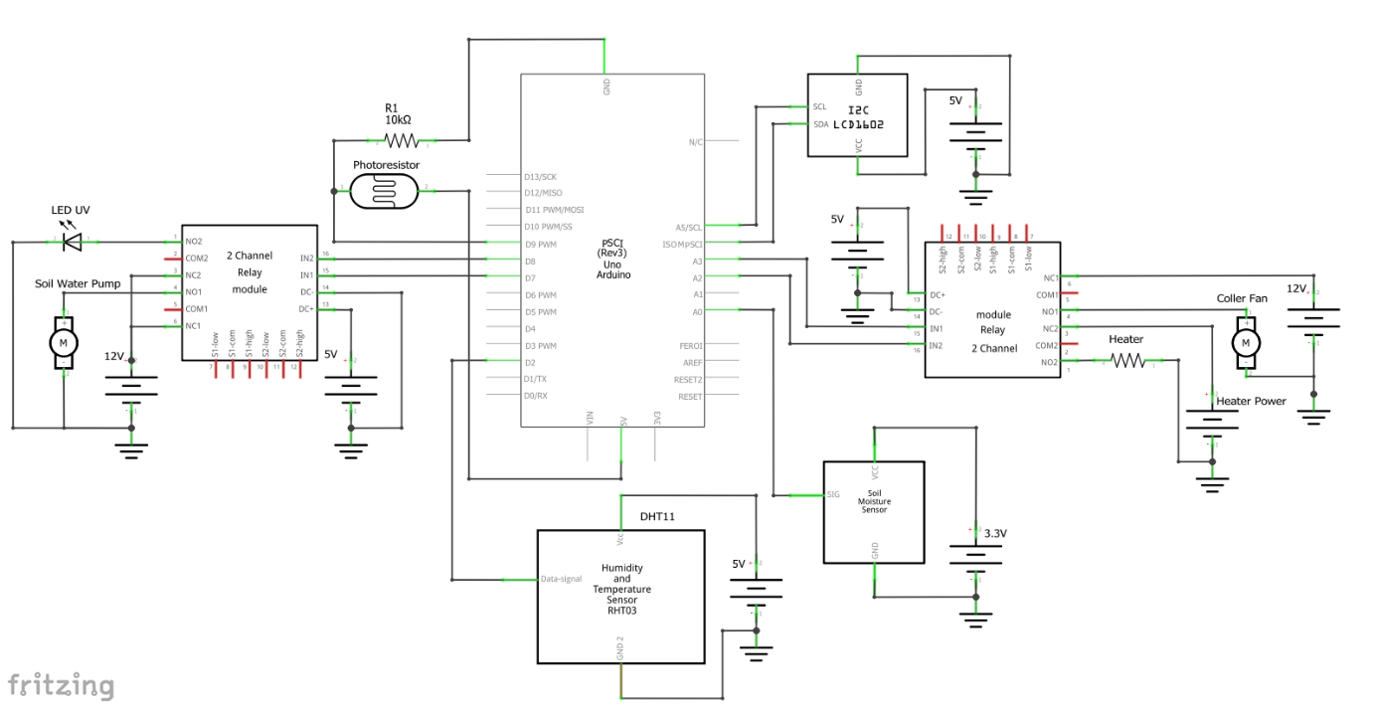
Fig. 1. Automation circuit of the greenhouse. Author: Mihály Konyicska

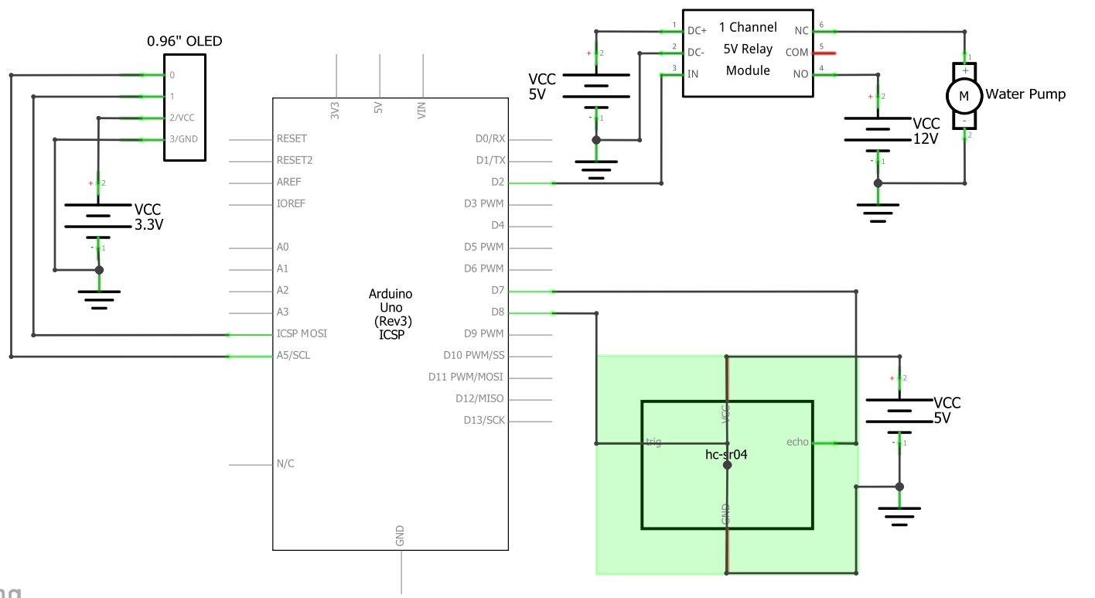
Fig. 2. Water tank monitoring circuit. Author: Mihály Konyicska

Conclusions

Therefore, automating a greenhouse using the Arduino platform is a promising approach for improving sustainability and profitability in agriculture.

Bibliography

[1] | https://en.wikipedia.org/wiki/Ultraviolet
[2] | https://en.wikipedia.org/wiki/Ultrasound
[3] https://natth.org/uv-c-si-plantele/
[4] https://lastminuteengineers.com/soil-moisture-sensor-arduino-tutorial/

