**THE PROBLEM OF POWER VARIATIONS IN WIND TURBINES THAT ARE WORKING AT TIME-VARYING WIND SPEEDS AND THE NEED FOR WIND ENERGY STORAGE**

EMIL-RADU EDU

Department of Mechanical Engineering

Politehnica University of Timișoara

Mihai Viteazu 1 Boulevard, Timișoara

ROMANIA

emil-roland.edu@student.upt.ro

SAMUEL CIUCURIȚĂ

Department of Electrical Engineering

Politehnica University of Timișoara

Vasile Pârvan 2 Boulevard, Timișoara

ROMANIA

samuel.ciucurita@student.upt.ro

*Abstract: -* In this paper it is demonstrated that a wind turbine, WT, which is operating at maximum power point, MPP, at significantly varying wind speeds large variations in the power injected into the grid occur. These power variations can be compensated if the wind system has storage facilities for captured wind energy. This experimental data from a 2.5 [MW] WT in operation in the Dobrogea area are processed.

*Key-Words: -*Wind system, wind turbine, time-varying wind speeds, points maximum power and power gaps, wind energy storage.

**1 Introduction**

This paper examines the need to equip wind power systems, which operate at time-varying wind speeds, with wind energy storage facilities, so that the operation of the wind turbine, WT, is at the maximum point of power, at the optimum mechanical angular velocity, MAV, $ω_{OPTIM}$ and optimal System Operation.

The National Power System, NPS, is not affected. In current systems, depending on the value of the wind speed, [1,9,10,11,12], it changes the load on the electrical generator, $P_{GE}$**,** based on the knowledge of the dependence of the optimum speed on wind speed. To achieve maximum wind energy capture at a given wind speed, the turbine, wind turbine, WT, must operate at the optimum MAV, ,or the optimal speed, $n_{OPTIM}$, [3,4,5,6].



WT operation at maximum power point, MPP, at angular mechanical velocity, MAV optimum, ,is a complex problem at variable wind speeds in due to the high mechanical inertia of the wind system, [18,19,21,22].



Achieving WT operation at optimum mechanical angular velocity at the point of power MPP, is based on changing the load on the electrical generator according to the value of the wind speed, $V$,[9,10,11,12].

We may use the notation TV for describing the Wind Turbine, WT, in the mathematical formulas.

WT power characteristic, function , has a maximum in MPP at angular velocity. Mechanical velocity, MAV optimum, , reference size in the control system. When operating at maximum power point, MPP, variation in wind speed over time imposes the time variation of the mechanical angular velocity .



At an energy-optimal control of the wind system, the time variation of the wind speed must be identical to the time variation of the mechanical angular velocity .



Obtaining electricity through large-scale expansion of wind power systems puts particularly important issues for the National Electricity System, NES, in terms of that [1,9,10,11,12]:

1. At time-varying wind speeds the electrical power supplied by the systems wind power, in NES, is variable, depending on the cube of the wind speed, at one WT operation in MPP, at the optimum mechanical angular velocity,



1. In order to achieve WT operation at the point of maximum power, at variable wind speed. In addition to the WT power varying significantly in time, it is necessary, due to equivalent moment of inertia, J of high value, generator power change so that the mechanical angular velocity is equal to the mechanical angular velocity optimum, [2, 7, 12]:



$$ω=ω_{OPTIM}=k_{V} ∙V$$

At large values of the equivalent moment of inertia, J, and at large variations in velocity

and therefore, at high values of its derivative, the power value of the generator, $P_{GE}$, can even become negative, which requires that it be switched to the motor, in which case power losses will occur.

1. Electrical power fluctuations, PGE, at WT operation at the point of maximum power are generated by:

-WT power dependent on wind speed cube

-inertial power, **P** INERTIALA dependent on wind speed and its derivative

$$P_{INERTIALA}=J\frac{dω}{dt}ω=J ⋅ k_{v}^{2}⋅\frac{dV}{dt} ⋅V$$

In cases where the variations in time of the optimal speeds, (optimal mechanical angular velocities), are identical to the variation of the wind speed in time, a **maximum of energy is captured**.

In the operation of wind systems, the variation of the value of the power injected into the NES is of interest.

From the point of view of NES stability, it is desired that the value of the power injected into the NES should be as constant as possible, [11,19,20,21,22] even if the value of the wind speed varies in time, which is a seemingly insoluble contradiction.

However, this problem can only be solved by building wind systems with wind energy storage facilities.

In the literature of the field of interest, [1,2,3,5,6,7,11,12,13,14], wind energy conversion; two important valid storage solutions could be identified:

1) Storage in batteries

2) Storage in hydraulic energy

In the reference [2] a system of hydraulic energy storage by pumping in hydro-towers is given, with an asynchronous generator with wound rotor.

Mechanical angular speed adjustment $ω$ is achieved by changing the rotor power of generator and therefore the power of the converter interposed between the generator rotor and the pump station is of reduced power.

The pillar supporting the nacelle is made as the upper reservoir, and as the lower reservoir is a lake or the sea (lower reservoir with a large volume capacity).

The rotor of the double-fed induction generator takes the power required by the system, hydraulic storage system based on the permanent magnet synchronous machine that works as motor, when pumping, or as a generator when converting hydro energy into electricity.

In the rotor circuit the power flow is bidirectional.

When wind energy is high, water is pumped from the water source in the lake to the hydro tower and released stored energy back into the lake or ocean when needed.

In [3] a wind system with synchronous generator and pumped storage on the Greek island of Ikaria is given.

The hybrid power plant consists of three hydropower units (H1: 1.05 MW + H2-3: 2 x 1.55 MW), all equipped with Pelton turbines, a pumping station with 8 pumps and 4 variable speed pumps of 0.25 MW each and a wind farm of 3 x 0.9 MW each.

In small island systems frequency and voltage control as well as power system stability are difficult problems at wind speeds that vary significantly over time.

Currently, the pump station is controlled to track electricity production, compensating for wind power variations that can disrupt frequency control.

The latter has been provided by diesel units, which need to be replaced by hydroelectric turbines if a high penetration of renewable energy sources is desired.

However, this introduces significant challenges for frequency regulation due to the slow response of hydropower units due to water column inertia and wind turbines.

In reference [4] a classical wind turbine pumped storage hydropower plant model from Tunisia is given, where the installed capacity of the WT is only 200 MW.

It is noted that a high penetration of wind energy in the country raises a problem of instability of the Tunisian energy system, caused by the intermittency and fluctuation of wind speed, which varies significantly over time.

This has an impact on the system frequency and voltage. It should, however, be mentioned that by using storage installations can eliminate these shortcomings.

**2 MAXIMUM ENERGY CAPTURE AND THE NEED FOR STORATE**

**The study is done at time-varying wind speeds and is based on the measurement of three fundamental quantities:**

* **wind speed, V,**
* **power, $P_{GE}$**
* **MAV, $ω$, at GE**

**In order for the wind turbine to operate at full power at time-varying wind speeds, it is necessary to change the load on the electrical generator, $P_{GE}$ depending on the value of the wind speed, [9,10,11,12].**

Capturing maximum wind energy, at time-varying wind speeds, in the absence of a storage system, significantly disrupts the operation of the National Power System, [8,12,23,25,26,27,28,29], creates **INSTALLABILITY IN THE ELECTROENERGETIC SYSTEM.**

**Remark 1**

The problem of storing wind energy at time-varying wind speeds becomes necessary when operating the wind turbine at the point of maximum power at mechanical angular velocity.

for at least the following reasons:

1) the operation of the National Electricity System is not affected

2) compensation for wind power fluctuations is achieved locally or regionally

3) the difference between grid energy demand and wind energy production is resolved

4) joint planning of electricity distribution and expansion for isolated systems can be carried out locally.

5) a flexible electricity resource can be realized with the help of short-term kinetic energy and long-term hydroelectric potential energy.

The simulations were based on the mathematical model of WT, which, in the authors' view, is the characteristic of WT power, function $P_{TV}(ω, V)$.

There are given in the literature, [6,7,11,12,13,14,15], various forms of the characteristic of WT power function:

$$P_{TV}(ω, V)$$

The most useful case is with 3 parameters: a, b, and c, of the form:

- power WT

where:

- air density in the WT's operating location; $R_{p}$-blade radius; $C_{p}(λ)$- power conversion coefficient; $λ=ωR_{p}/V$; $V$-wind speed; $ω$- mechanical angular velocity, MAV.

Parameters: a, b and c are determined by measurement:

-wind speed, $V$;

-power flow, $P_{G}$ and

speed/MAV at GE, $n/ω$,

The most accurate knowledge of the mathematical model of WT (MM-WT) is essential in controlling the system and ensuring that the wind turbine operates at full power.

The determination of the mathematical model of WT, (MM-WT), is based on experimental data.

From the 2.5[MW] WT type: GEWE-B2.5-100-in operation in the Dobrogea area, location Galbiori, [1], having the following characteristics:

* three bladed rotor - diameter 100m

GEWE-B2.5-100

* area covered by the rotor- 7854 $m^{2}$
* the value of the moment of inertia,

$J=5372.5[{kgm}^{2}]$

* rotation 6-6,15rot/min;
* direction of rotation of the rotor – clockwise;
* automatic wind direction orientation;
* rotor mounting tower - modular cylinder consisting of 4 segments;
* diameter at the top of the tower- 2,3m;
* diameter at the base of the tower- 4,15m;
* rotor blades are made of composite material;

The mathematical model of WT, (MM-WT), used in the simulation has the form,[1].

$$P_{TV}\left(ω, V\right)==6. 5086 x {10}^{5}(V/ω- 1. 7488 x {10}^{2})e^{-41.495\left(V/ω\right)}V^{3}[W]$$

The value of WT power $P_{TV}(ω, V)$,depends on the value of the wind speed, $V$ and the value of the mechanical angular velocity $ω$.

The maximum power at wind speed V is obtained at the value of the optimum mechanical angular velocity, $ω_{OPTIM}$

$$ω_{OPTIM}\left(V\right)=24.046 ⋅V[{rad}/s]$$

value obtained by cancelling the WT power derivative,

$$\frac{dP_{TV}(ω, V)}{dω}=0$$

The value of the wind speed, [9,10,11,12], changes over time and the wind system is always in a transient regime, which is analyzed with the kinetic momentum equation, [2,3,5,6,7]:

$$J\frac{dω}{dt}=M_{TV}-M_{GE}$$

where: $ω$-mechanical angular velocity, MAV, at the generator shaft generator, GE, J equivalent moment of inertia, $\frac{dω}{dt}$- derived with respect to time of MAV, $M_{TV}$

-the time, relative to the generator tree, given by WT,

$M_{GE}$-electromagnetic moment at the GE shaft

By multiplying $ω$ the kinetic momentum equation by, the power equation is obtained:

$$J\frac{dω}{dt}ω=P_{TV}-P_{GE}$$

or with inertial power

$$P_{INERTIALA}=P_{TV}-P_{GE}$$

Where: $P_{TV}$-the useful power given by the WT, referred to the electric generator shaft,

$P_{GE}$-electromagnetic power of the GE, at the shaft.

By solving the equation of the kinetic momentum, it is possible to visualize the evolution of the process, [12,13,15,16,17], in the dynamic regime, at variable speeds, [1,2,3,5,6,7]:

In order to achieve, at a given wind speed, a maximum wind energy capture, the WT must operate at optimal MAV, $ω_{OPTIM}$ [3,4,5,6].

Based on the knowledge of the dependence of optimum speed on wind speed

$$ω=ω_{OPTIM}=k_{v}⋅V$$

Resulting:

$$J\frac{dω_{OPTIM}}{dt}ω_{OPTIM}==p_{TV-MAX}-P_{GE-OPTIM}$$

This gives the optimum power to the electric generator:

$$P_{GE-OPTIM = }P_{TV-MAX}-J⋅k_{V}^{2}⋅\frac{dV}{dt}⋅V==k_{P}⋅V^{3}-J⋅k_{V}^{2}⋅\frac{dV}{dt}⋅V$$

Electric power fluctuations, $P_{GE-OPTIM}$, are generated by -power WT through the $k_{P}⋅V^{3}$

-inertial power $J⋅k_{V}^{2}⋅\frac{dV}{dt}⋅V$ by the wind speed V and its derivative $\frac{dV}{dt}$

At large values of the equivalent moment of inertia, J and at large variations of the wind speed, in increasing direction, therefore at large values of its derivative, $\frac{dV}{dt}$, the value of $P_{GE-OPTIM}$ decreases and may even become negative.

These power fluctuations, in the absence of storage facilities, are transmitted to the grid and create instability in the NES.

They are further analyzed at the equivalent moment of inertia value:

$$J=511. 92[{kgm}^{2}]$$

optimal electromagnetic power is obtained:

$$P_{GE-OPTIM}=P_{TV-MAX}-{ 24. 046}^{2}⋅511. 92\frac{dV}{dt}⋅V$$

and with:

$$P_{TV-MAX}=2792. 8⋅V^{3}$$

Resulting:

$$P_{GE-OPTIM}=2792. 8⋅V^{3}-2. 96×{10}^{5}\frac{dV}{dt}⋅V$$

The actual wind speed variation is given in Figure 1 and is at the Galbiori location,[1], on 15.06.2022.

By analyzing in more detail, over the time intervals A-B and B-C, given in figure 1. the actual variation of wind speeds the optimal power to the electric generator is determined, $P_{GE-OPTIM}$, so that the wind turbine operates at full power.

Fig.1.Actual wind speed variation

The wind speed at points A, B and C has the values:

|  |  |  |
| --- | --- | --- |
| t[s] | V[s] | Point |
| 0 | 10.47 | Point A |
| 3.433 | 9.13 | Point B |
| 6.631 | 9.52 | Point C |

A linear variation of wind speed from point A to point B gives:

$$V\left(t\right)=10.47+\frac{8.13-10.47}{3.433}t=\left(10.47-0.73171t\right)$$

and the power of WT is:



The WT at point A is assumed not to operate at the point of maximum power, the value MAV being:



**2.1. Bringing the wind system to full turbine power**

Bringing the system to the point of maximum turbine power requires acceleration to optimum MAV, which is achieved in the shortest time by two methods:

1)decoupling the GE from the grid (slower method)

2)switching the genset to engine mode (faster method)

The GE is considered to be disconnected from the grid and has MAV of value:



From the equation of powers of form



is obtained:

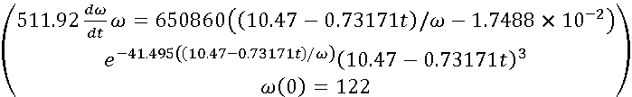

and, by solving it, results in the time variation of the mechanical angular velocity $ω$ At time t*, as shown in Figure 2 $ω$ has the value:



approximately the same as optimum MAV:



$24.046⋅\left(10.47-0.73171⋅3.3\right)=$

$$=197.67\left[rad/s\right]$$

# 

At t3.3[s] the values of the optimum mechanical angular velocities, $ω_{OPTIM}$ and real, $ω$, being equal, the system operates at the turbine's maximum power point.

Fig.2.Variations of optimal and actual mechanical angular velocities

At time t* the wind speed has the value:

$$V\left(3.3\right)=10.47+\frac{8.13-10.47}{3.433}3.3=8.2207\left[m/s\right]$$

and from the characteristic of WT power $P_{TV}(V, ω)$, to, $ω(3.3)$



it gets the power developed by WT, of value:



**2.2. Maintaining the wind system at full turbine power**

From the power equation, when operating in MPP, the electromagnetic power is obtained, $P_{GE}$,to the electric generator shaft:



In the energy-optimal zone, at MPP operation, the optimum mechanical angular velocity value, $ω_{OPTIM}$, depends on the value of the wind speed as:



In the optimum zone the value of the current mechanical angular velocity $ω$ must be equal to the value of the optimum mechanical angular velocity, $ω_{OPTIM}$



so, the equation of powers becomes:



Or:

$$24.046⋅J\frac{dV}{dt}24.046⋅V==P_{TV-MAX}-P_{GE-OPTIM}$$

In this way, based on the knowledge of the dependence of the optimum speed on the wind speed, the optimum power of the electric generator is obtained.

$$P_{GE-OPTIM}=P_{TV-MAX}-24.046^{2}⋅J\frac{dV}{dt}⋅V$$

At the equivalent moment of inertia of value:

$$J=511.92\left[kgm^{2}\right]$$

optimal electromagnetic power is obtained:

$$P_{GE-OPTIM}=P_{TV-MAX}-24.046^{2}⋅511.92\frac{dV}{dt}⋅V=2792. 8⋅V^{3}- 2. 96×{10}^{5}\frac{dV}{dt}⋅V$$

After the WT has been brought into the MPP, at time $t^{*}$, the GE connects to the grid and charges to power:



By simulation a check is made in the MPP area with the location of the moments of time when power gaps occur.

* 1. **Time intervals when wind speed increases and power gaps occur**

From the analysis of the actual wind speed variation given in Figure 1, it can be seen that there are time intervals when the wind speed increases, and time intervals when the wind speed decreases.

Imposing an operation in the MPP zone, optimal power to the electric generator, $P_{GE-OPTIM}$,will have a variation imposed by the wind and it is possible that there will be time intervals where power gaps may occur.

**CASE STUDY 1 - The appearance of power gaps**

The operation of the system is analyzed after it has been brought to full power of the turbine.

Consider that, at time $t^{*}$, the WT is operating at the point of maximum power, point B, figure 1.

|  |  |  |
| --- | --- | --- |
| t[s] | V[m/s] | Point |
| 0 | 10.47 | Point A |
| 3.433 | 8.13 | Point B |
| 6.631 | 9.52 | Point C |

At the moment of time $t^{*}=0$

the system operates in B, at the point of maximum turbine power, at equal values of the optimum mechanical angular velocities, and real, $ω$:



Wind speed value being:

$$V^{*}=8.13\left[m/s\right]$$

GE charging is at $P_{GE}^{*}$ power value:



On the interval B-C considering the wind speed variation as linear, it results:

$$V_{B-C}\left(t\right)=8.13+\frac{9.52-8.13}{6.631-3.433}t$$

Wind energy captured $E_{eoliana}$, can be calculated by integrating the WT power:

$$E_{eoliana}=\int{P_{TV}}⋅dt$$

Or

$$\frac{E_{eoliana}}{dt}=P_{TV}$$

The B-C interval is divided into 4 subintervals:

subinterval 1

Sampling being 1s, at

$t^{*}=1\left[s\right]$

results in the value of the wind speed

$$V_{1}^{*}=8.13+\frac{9.52-8.13}{6.631-3.433}1=8.5646\left[m/s\right]$$

Wind speed has a linear variation from 8.13[m/s] to 8.564 6[m/s]

$$V_{B-C-1}\left(t\right)=8.13+\left(8.5646-8.13\right)t=0.4346t+8.13$$

and optimum mechanical angular velocity, is:



and the equations of motion and energy are obtained as:

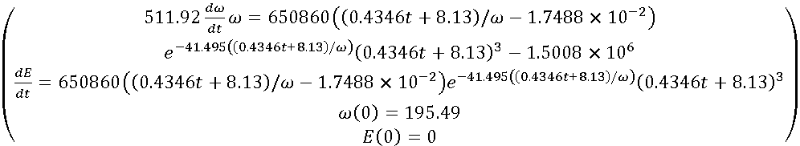

In one second, valuable wind energy is captured:



When operating at the point of maximum power, the wind energy captured in the same range time has the value:

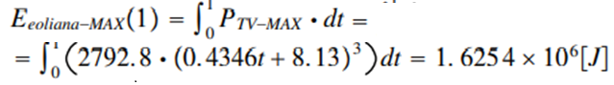

In the same time interval, the electrical energy flowed has the value:



Fig.3.Optimal and actual MAV variations on subinterval 1

At $t^{*}=1\left[s\right]$ Figure 3, mechanical angular velocity, $ω$ has the value:



compared to the optimum mechanical angular velocity:



Because

$$ω_{OPTIM-1}>ω(1)$$

At $t^{*}=1\left[s\right]$ the full power point of the turbine has not been reached.

The value of inertial power being positive, $P_{INERTIAL}^{*}>0$



decreases, on subinterval 2, the GE load at power



Subinterval 2

At $t=2\left[s\right]$

the value of the wind speed is:

$$V_{2}^{*}=8.13+\frac{9.52-8.13}{6.631-3.433}2=8.9993\left[m/s\right]$$

On subinterval 2 the wind speed has a linear variation from 8. 564 6[m/s] to 8. 999 3[m/s]

$$V_{B-C-2}\left(t\right)=8.5646+\left(8.9993-8.5646\right)t=0.4347t+8.5646$$

and the optimum mechanical angular velocity, , is:



**Specification 1**

In subinterval 2, compared to subinterval 1, the origin of time shifted by 1 second and this is repeated in each subinterval analyzed.

The equations of motion and energy are obtained as:

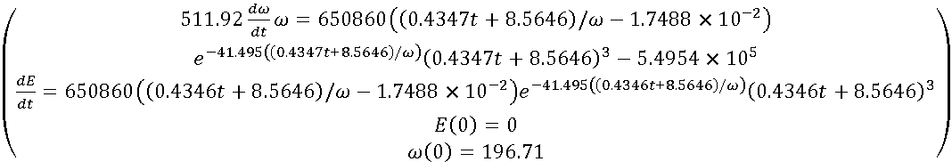

It captures valuable wind power in a second:



At MPP operation the wind energy captured in the same time interval has the value

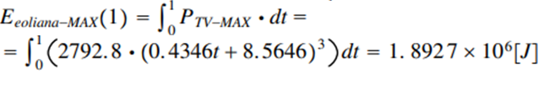

The electricity delivered has the value:





Fig.4.Optimal and actual MAV variations on subinterval 2

At $t^{*}=1\left[s\right]$ mechanical angular velocity $ω$ has the value



being lower compared to the optimal mechanical angular velocity, Figure 4



Because

$$ω_{OPTIM-2}>ω(1)$$

At $t^{*}=1\left[s\right]$ the full power point of the turbine has not been reached.

The value of inertial power being positive, $P_{INERTIAL}^{*}>0$



the GE loading should decrease in subinterval 3 to



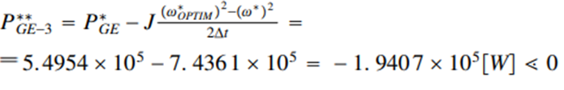

**The power value of the GE being negative it requires it to be switched to engine mode**

**Remark 2**

Because the value of the actual mechanical angular velocity, $ω$, to reach, on subinterval 3, the value of the optimum mechanical angular velocity $ω_{OPTIM}$ GE must be switched to engine mode, which is practically difficult to achieve and for this reason the generator is disconnected from the grid.

subinterval 3

As the power value at the GE is negative in subinterval 3, it discharges and therefore:

$P_{GE-3}^{**}=0$

At $t=3\left[s\right]$

the value of the wind speed is:

$$V_{3}^{*}=8.13+\frac{9.52-8.13}{6.631-3.433}3=9.4339\left[m/s\right]$$

On subinterval 3 the wind speed has a linear variation from 8. 999 3[m/s] to 9. 433 9[m/s]

$$V_{B-C-3}\left(t\right)=8.9993+\left(9.4339-8.9993\right)t=0.4346t+8.9993$$

and the optimum mechanical angular velocity, $ω_{OPTIM}$, is:



and we obtain the system of differential equations of motion and energy in the form:

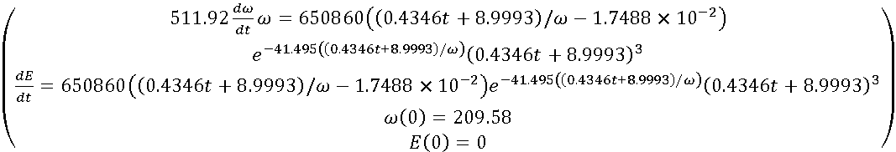

It captures valuable wind energy in a second:



At MPP operation the wind energy captured in the same time interval has the value:

$$E_{eoliana-MAX}\left(1\right)=\int_{0}^{1}{P_{TV-MAX}}⋅dt=\int_{0}^{1}{(2792.8⋅(0.4346t+8.9993)^{3})}dt=2.1877×{10}^{6}[J]$$

Electricity flowed is zero:

Fig.5.Optimal and actual MAV variations on subinterval 3

At $t^{*}=1\left[s\right]$ Figure 5, the mechanical angular velocity $ω$ has the value:



and exceeded the optimum mechanical angular velocity:



At the moment of time $t_{3}$ Figure 5, mechanical angular speed $ω$ reached the value of the optimum mechanical angular velocity.

At this point in time the wind turbine is operating at the point of maximum power at the optimum speed of mechanical angular velocity.

The value of captured wind energy is reflected in the electrical energy delivered to the system and in the kinetic energy of the rotating masses.

On the 3 subintervals the kinetic energies are



In conclusion, on the 3 subintervals the energies and powers flowed are:

|  |  |  |  |  |
| --- | --- | --- | --- | --- |
| subinterval | $$E_{eoliana}[J]$$ | $$E_{eoliana-MAX}[J]$$ | $$P_{GE}[W]$$ | $$ΔE_{cinetic}[J]$$ |
| 1 | 1.6236 x ${ 10}^{6}$ | 1.6254 x ${10}^{6}$ | 1.5008 x ${10}^{6}$ | 1.2447 x ${10}^{5}$ |
| 2 | 1.8883 x ${ 10}^{6}$ | 1.8927 x ${ 10}^{6}$ | 5.4954 x ${10}^{5}$ | 1.3384 x ${10}^{6}$ |
| 3 | 2.1869 x ${ 10}^{6}$ | 2.1877 x ${ 10}^{6}$ | 0 | 2.1871 x ${ 10}^{6}$ |

Over an interval of 3 s, in which the wind speed increases:

8.13[m/s] < V(t) < 9.4339[m/s]

The energy evolutions are given in figure 6.

Fig.6.Variations of captured wind energy and electrical power

The energy balance confirms that the wind energy captured $E_{eoliana}$,is found in the electricity flowed $E_{electrica}$ and the kinetic energy of rotating masses, $ΔE_{cinetic}$

energy balance on subinterval 1

is found in:



energy balance on subinterval 2

is found in:



energy balance on subinterval 3

is found in:



The overall energy balance on interval 1 $⟹$ 3 is



**Remark 3**

At the moment of time $t_{3}$ maximum wind energy is captured, although it discharges GE, $(P_{GE}^{**}=0)$

The turbine operates in MPP, at optimum speed mechanical angular velocity, energy that is not fed into the system. $(P_{GE-3}^{**} is zero)$*but is found in the kinetic energy of rotating masses.*

Apparently, the operation of the turbine is not in the optimal zone from an energy point of view. Being a power vacuum at this point in time is a disadvantage for the stability of the energy system.

**Observations** resulting from the variations in energy values, given in Figure 6.

1) Values of the electrical energies flowed $E_{electrica}$, decrease, (generator power decreases)

2) Differences in kinetic energy values $ΔE_{cinetic}$ increase and compensate for the decrease in electrical energy output

3) The values of wind energy captured increase directly proportional to the increase in wind speed.

In conclusion, during time intervals in which the wind speed increases power gaps may occur, if the values of the wind speed derivative $\frac{dV}{dt}$ and the equivalent moment of inertia J exceed certain values.

**2.4. Time intervals when wind speed decreases**

**CASE STUDY 2 - MPP area at decreasing wind speed**

From Figure 7 choose the time interval **D-E**, in which the wind speed decreases.

|  |  |  |
| --- | --- | --- |
| **t[s]** | **V[m/s]** | **Point** |
| **1.198** | **10.47** | **start** |
| **39.858** | **9.52** | **Point D** |
| **43.073** | **7.145** | **Point E** |

At point D, Figure 7, the WT is assumed to operate at the point of maximum power at equal values of the optimum mechanical angular velocities $ω_{OPTIM}$ and real, **:**



Fig.7. **D-E** time interval with decreasing wind speed

Wind speed value being:

$V_{D}=9.52\left[m/s\right]$

GE charging is at power $P_{GE-D}$ valuable:



On the interval **D-E** considering the wind speed variation as linear, it results:

$V_{D-E}\left(t\right)=9.52+\frac{7.145-9.52}{43.073-39.858}t=9.52-0.73872t$

The **D-E** interval is divided into 3 subintervals:

**Subinterval 1**

Sampling being from 1s, to:

$$t^{*}=1\left[s\right]$$

results in the value of the wind speed:

$V_{1}^{*}=9.52+\frac{7.145-9.52}{43.073-39.858}1=8.7813\left[m/s\right]$

Wind speed has a linear variation from

$9.52\left[m/s\right]$ to $8.7813\left[m/s\right]$

$$V_{D-E-1}\left(t\right)=9.52+\left(8.7813-9.52\right)t=9.52-0.7387t$$

and the optimum speed mechanical angular velocity $ω_{OPTIM}$ is:



and the equations of motion and energy are obtained as:

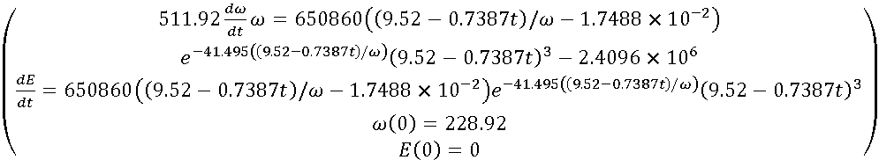

In one second, valuable wind energy is captured:



When operating at the point of maximum power, the wind energy captured in the same time interval has the value:

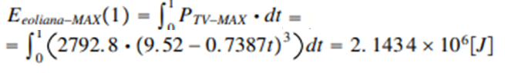

In the same time interval, the electrical energy flowed has the value:





Fig.8.Optimal and actual MAV variations on subinterval 1

At $t^{*}=1\left[s\right]$ Figure 8, mechanical angular velocity $ω$ have the value:



compared to the optimum mechanical angular velocity



Because

$$ω_{OPTIM-1}<ω(1)$$

the value of inertial power being negative, $P_{INERTIALA}^{*}<0$



increases, on subinterval 2, the GE loading at power



**Subinterval 2**

At t = 2[s]

the value of the wind speed is:

$V_{2}^{*}=9.52+\left(8.7813-9.52\right)2=8.0426\left[m/s\right]$

Wind speed has a linear variation from $8.7813\left[m/s\right]$ to $8.0426\left[m/s\right]$

$$V_{D-E-2}\left(t\right)=8.7813+\left(8.0426-8.7813\right)t=8.7813-0.7387t$$

and optimum mechanical angular velocity, is:



and the equations of motion and energy are obtained as:

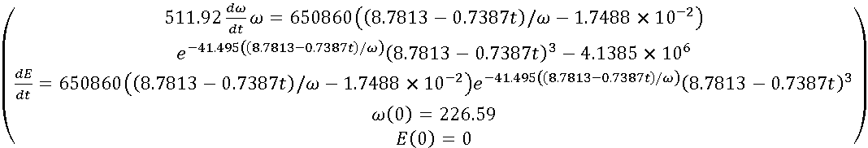

In one second, valuable wind energy is captured:



When operating at the point of maximum power the wind energy captured in the same time interval has the value:



In the same time interval, the electrical energy flowed has the value:



At $t^{*}=1\left[s\right]$ mechanical angular velocity $ω$ has the value



compared to the optimum mechanical angular velocity



Because: $ω_{OPTIM-2}$ < $ω(1)$

the value of inertial power being negative, $P_{INERTIALA}^{*}<0$



the GE load is increased in subinterval 3 to power:



**Subinterval 3**

To t = 3[s]

the value of the wind speed is:

$V_{3}^{*}=9.52+\left(8.7813-9.52\right)3=7.3039\left[m/s\right]$

Wind speed decreases from $8.0426\left[m/s\right]$ to $7.3039\left[m/s\right]$

$V_{D-E-3}\left(t\right)=8.0426+\left(7.3039-8.0426\right)t=8.0426-0.7387t$

and optimum mechanical angular velocity is:



and the equations of motion and energy are obtained as:

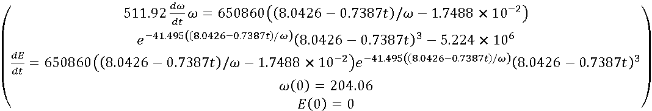

In one second, valuable wind energy is captured:



When operating at the point of maximum power the wind energy captured in the same time interval has the value:

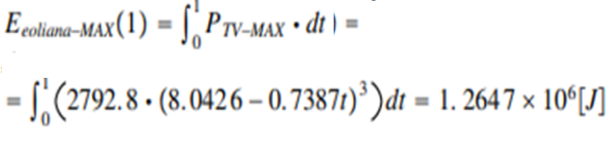

In the same time interval, the electrical energy flowed has the value:



At $t^{*}=1\left[s\right]$ mechanical angular velocity has the value:



compared to the optimum mechanical angular velocity



At the time $t_{3}$, Figure 9, the optimum mechanical angular velocity, is equal to the mechanical angular velocity $ω$ The maximum power point is reached, and the tuning algorithm is validated.





Fig.9.Optimal and actual MAV variations on subinterval 3

Because $ω_{OPTIM-3}$ > $ω(1)$



the value of inertial power is positive, $P_{INERTIALA }^{*}$ > 0



should, over the next sub time interval, decrease the GE load to the power:

The value of the wind energy captured is reflected in the electricity delivered to the system and in the kinetic energy of the rotating masses.



On the 3 subintervals the variations of kinetic energies are:



In conclusion, on the 3 subintervals the powers and energies are:

|  |  |  |  |  |
| --- | --- | --- | --- | --- |
| Subinterval | $$E_{eoliana}[J]$$ | $$E_{eoliana-MAX}[J]$$ | $$P_{GE}[W]$$ | $$ΔE_{cinetic}[J]$$ |
| 1 | 2.1382 x ${10}^{6}$ | 2.1434 x ${10}^{6}$ | 2.4096 x ${10}^{6}$ | -2.7166 x ${10}^{5}$ |
| 2 | 1.6549 x ${10}^{6}$ | 1.6656 x ${ 10}^{6}$ | 4.1385 x ${10}^{6}$ | -2.4835 x ${10}^{6}$ |
| 3 | 1.2619 x ${10}^{6}$ | 1.2647 x ${10}^{6}$ | 5.224 x ${10}^{6}$ | -3.9624 x ${10}^{6}$ |



Fig.10.Variations of captured wind energy and electrical power

Over an interval of 3 s, in which the wind speed decreases:



The evolution of the captured wind energy and the electrical power output are given in Figure 10:

$E_{eoliana}=E_{electrica}+ΔE_{cinetic}$

and the resulting 3 subintervals:

Subinterval 1

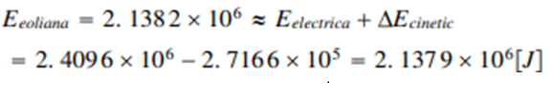

Subinterval 2

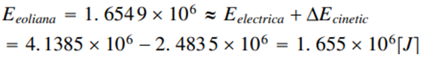

Subinterval 3

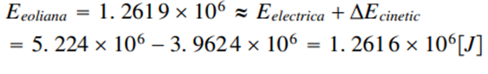

**Remark 4**

During the time intervals when the wind speed decreases, no power gaps occur, although the mechanical angular velocity $ω$ tends towards the value of the optimum mechanical angular velocity The turbine does not operate in the MPP area and yet the power delivered to the system is greater than the power given by the WT, the difference being from the kinetic energy of the rotating masses. For the stability of the energy system this is an advantage.



**Observations** resulting from the variations in energy values, given in Figure 10.

1) The values of electrical power flow, $P_{GE}$ increase, although the wind speed decreases

2) Differences in kinetic energy values $ΔE_{cinetic}$ in absolute terms, they also increase

compensate for the decrease in the value of wind energy captured.

3) The values of wind energy captured decrease directly proportional to the decrease in wind speed

In conclusion, during the time intervals when wind speed decreases no power gaps occur and, on the contrary, there is an increase in electrical power, whatever the values of the derivative of the velocity of the wind, $\frac{dV}{dt}$ and the equivalent moment of inertia J.

This extra electrical power comes, as mentioned, from the kinetic energy of rotating masses.

The surplus power must be stored and only the electrical energy predicted in advance is given to the NES.

**3. RESULTS AND DISCUSSION**

**3.1 RESULTS**

As a result of the presented study the following results were obtained:

As a result of the presented study the following results were obtained:

1) It has been demonstrated the need to equip wind systems, operating at speeds of

wind speeds variable in time, with wind energy storage installations, so that wind turbine operation is at its maximum power point at angular velocity and the operation of the National Power System is not disturbed.

2) The evolution of the process has been analyzed with the equation of the kinetic momentum, because, at speeds of the wind turbine operates in a dynamic regime.

3) The time intervals at which power gaps occur were analyzed

4) The time intervals at which the wind speed decreases have been analyzed.

**3.2. FUNDAMENTAL ISSUES**

**With the results obtained the following relevant aspects can be highlighted:**

**1)It has been shown that in the time intervals in which the wind speed increases the power output in the system decreases, if the turbine operates at the point of maximum power.**

**2) It has been shown that in the time intervals when the speed decreases the power flow in the**

**system is higher than the power given by the turbine, this is an advantage for the stability of the power system.**

**3) It has been demonstrated that the turbine can operate at full power at any wind speed, regardless of the restrictions imposed, if a wind energy storage system is available.**

**4) Bringing the system to the turbine's full power point is done in the shortest time by: disconnecting the GE from the grid or by switching the GE to engine mode**

**5) By estimating the difference between the optimum mechanical angular velocity and the current mechanical angular velocity, the power value at the generator can be prescribed**

**6) During the time intervals when the wind speed increases, power gaps occur (disconnect the generator from the grid), if operation in the optimal zone from the energy point of view is required.**

**7) During the time intervals when the wind speed decreases, no power losses occur, even if operation in the energy-optimal zone is required.**

**3.3 DISCUSSION**

1) The method presented is based on a control that considers wind speed and mechanical angular velocity.

2) The system is brought to the point of maximum power by calculating the values of the variations of the kinetic energies of the rotating masses, values obtained by measurements.

3) At increasing wind speeds over time, power gaps occur under the condition that operation at the point of maximum power is required.

4) At decreasing wind speeds over time no power losses occur, although operation at the point of maximum power is required and the electrical power delivered to the system is greater than the power given by the turbine, the surplus power coming from the varying kinetic energies of the rotating masses.

**4. CONCLUSIONS**

In this paper it has been shown that wind energy storage is necessary when the wind turbine is operating at full power point. the power output of generator comes from the power developed by the wind turbine and from the variation of the kinetic energies of the rotating masses, energy stored in them during the time when there is a significant decrease in wind speed (statement interesting and may seem contradictory). It has been shown that operation in the energy-optimal zone, at the point of maximum turbine power, requires a storage system for captured wind energy. The behaviour of the wind turbine at time-varying wind speeds was analyzed and it was observed that, at significant variations in wind speed, the prescribed value at the generator can be negative, in which case a power gap is created in the national power system. The optimal area from the point of view of the simulations presented were based on real wind speed variations at turbines in the Dobrogea area.

**5. BIBLIOGRAPHY**

[1]http://www.monsson.eu/locatia DOBROGEA,ROMANIA, anul 2022 [2]Hua Ye, Yujun Ding, Liye Xiao, Qionglin Li, Chen Zheng, Yi Wang "Hydro-Tower Pumped Storage-based Wind Power Generator: Short-term Dynamics and Controlse"https://ieeexplore.ieee.org/stamp/stamp.jsp?tp&arnumber10455726 [3] A. Papakonstantinou, A..Konstanteas,S.tavros, A. Papathanassiou, "Solutions to Enhance Frequency Regulation in an Island System With Pumped-Hydro Storage Under 100% Renewable Energy Penetratione",IEEE POWER & ENERGY SOCIETY SECTION Received 22 June 2023, accepted 13 July 2023, date of publication 19 July 2023, date of current version 28 July 2023

[4] J. Jamii, F. Mimouni, ”Model of wind turbine- pumped storage hydro plant Model of wind turbine- pumped storage hydro plant ”The 9th International Renewable Energy Congress 2023 2nd Asian Conference on Frontiers of Power and Energy (ACFPE) | 979-8-3503-0389-6/23/$31.00 ©2023 IEEE | DOI: 10.1109/ACFPE59335.2023.10455726 [5]C. Sorandaru, V. Muller, M.G. Erdodi, E.R. Edu, M.C. Ancuti, S. Musuroi, M. Svoboda, "Fundamental Issue for Wind Power Operating at Variable Wind Speeds: the Dependence of the Optimal Angular Speed on the Wind

Speed",Iasi,Romania,2022,International Conference and Exposition on Electrical And Power Engineering (EPE) 978-1-6654-8994-2/22/$3.00 © 2022 IEEE | DOI: 10.1109/EPE56121.2022.9959751, pp. 167-171 [6]. E. Rebello , D. Watson, and M. Rodgers" Performance Analysis of a 10 MW Wind Farm in Providing Secondary Frequency Regulation: Experimental Aspects " IEEE TRANSACTIONS ON POWER SYSTEMS, VOL. 34, NO. 4, JULY 2019 [7] P. Huynh, S. Tungare, and A. Banerjee, “Maximum Power Point Tracking for Wind Turbine Using Integrated Generator–Rectifier Systems” IEEE TRANSACTIONS ON POWER ELECTRONICS, VOL. 36, NO. 1, JANUARY 2021 [8]MA Yufei,ZHANG Li, et. al., "Inception mechanism of lighting upward leader form the wind turbine blade and a proposed critical length criterion", Proceedings of the CSEE, vol. 36, pp. 5975-5982, 2016 [9] J. Hussain and Mahesh K. Mishra, “An Efficient Wind Speed Computation Method Using Sliding Mode Observers in Wind Energy Conversion System Control Application”, IEEE TRANSACTIONS ON INDUSTRY APPLICATIONS, VOL. 56, NO. 1, JANUARY/FEBRUARY 2020 [10] M. Edrah , X. Zhao , W. Hung , P. Qi , B. Marshall, A. Karcanias, and S. Baloch, “Effects of POD Control on a DFIG Wind Turbine Structural System”, IEEE TRANSACTIONS ON ENERGY CONVERSION, VOL. 35, NO. 2, JUNE 2020 [11] C. Sorandaru, S. Musuroi, F.M. Frigura-Iliasa, D. Vatau, M. Dordescu, "Analysis of the Wind System Operation in the Optimal Energetic Area at Variable Wind Speed over Time," Sustainability (2071-1050), 3/1/2019, Vol. 11 Issue 5, p1249. [12] M.Babescu "Masina sincrona-Modelare-identificare-simulare"Editura POLITYEHNICA Timisoara,ISBN 973-625-021-0,2003 [13] X. Deng, J. Yang, Y. Sun, D. Song, Y. Yang, and Young H. Joo, “An Effective Wind Speed Estimation Based Extended Optimal Torque Control for Maximum Wind Energy Capture”, 10.1109/ACCESS.2020.2984654 [14] R. Karthik, A. Sri Hari, Y. V. Pavan Kumar, and D. John Pradeep, “Modelling and Control Design for Variable Speed Wind Turbine Energy System”, 2020 International Conference on Artificial Intelligence and Signal Processing (AISP) [15] G. Srinivasa Sudharsan, J. Vishnupriyan, and K. Vijay Anand, “Active flow control in Horizontal Axis Wind Turbine using PI-R controllers”, 2020 6th International Conference on Advanced Computing & Communication Systems (ICACCS) [16] S.Goyal (MIET), Shree K. Maurya, S. Kumar, and D. Agarwal, “A Consolidation Review of Major Wind Turbine Models in Global Market”, 2020 International Conference on Power Electronics & IoT Applications in Renewable Energy and its Control (PARC) GLA University, Mathura, UP, India. Feb 28-29, 2020 [17] Y. Baala, and S. Bri, “DFIG-Based Wind Turbine Control Using High-Gain Observer”, 978-1-7281-4979-0/20/$31.00 ©2020 IEEE [18] Y. Najih, M. Adar, A. Aboulouard, Z. Khaouch, M. Bengourram, M. Zekraoui, and M. Mabrouki, “Mechatronic Control Model of a Novel Variable Speed Wind Turbine Concept with Power Splitting Drive Train: A Bond Graph Approach”, 978-1-7281-6654-4/20/$31.00 ©2020 IEEE [19] S. Vadi, Fethi B. Gürbüz, R. Bayindir, and E. Hossain, “Design and Simulation of a Grid Connected Wind Turbine with Permanent Magnet Synchronous Generator”, 8th IEEE International Conference on Smart Grid June 17-19, 2020, Paris, FRANCE [20] C. Carstea, F. Butaru, M. Codruta Ancuti, S. Musuroi, A. Deacu, M. Babaita, and Alin M. Stanciu, “Wind Power Plants Operation at Variable Wind Speeds”, SACI 2020 IEEE 14th International Symposium on Applied Computational Intelligence and Informatics May 21-23 Timişoara, Romania [21] A. Yingyu, Y. Li, J. Zhang, T. Wang and C. Liu, “Enhanced Frequency Regulation Strategy for Wind Turbines Based on Over-speed De-loading Control”, 978-1-7281-5281-3/20/$31.00 ©2020 IEEE [22] E. Dobrin, M. Codruta Ancuti, S. Musuroi, C. Sorandaru, R. Ancuti and M. Alexandra Lazar, “Dynamics of the Wind Power Plants at Small Wind Speeds”, SACI 2020 IEEE 14th International Symposium on Applied Computational Intelligence and Informatics May 21-23 Timişoara, Romania [23] X. Fan , E. Crisostomi , B. Zhan , and D. Thomopulos, “Rotor Speed Fluctuation Analysis for Rapid De-Loading of Variable Speed Wind Turbines”, 978-1-7281-5200-4/20/$31.00 ©2020 IEEE [24] B. Singh Pali , and S. Vadhera, “An Innovative Continuous Power Generation System Comprising of Wind Energy Along With Pumped-Hydro Storage and Open Well”, IEEE TRANSACTIONS ON SUSTAINABLE ENERGY, VOL. 11, NO. 1, JANUARY 2020 [25]Shigeru Yokoyama, Yoh Yasuda, et. al. "Clarification of the mechanism of wind turbine blade damage taking lighting characteristics into consideration an relevant research project", International Conference on Lighting Protection, Vienna, Austria, pp. 1-6, 2012 [26]Yao Xingjia, Liu Yingming, Bao Jieqiu, Xing Zuoxia, "Research and Simulation of Direct Drive Wind Turbine VSCF Characteristic", Proceedings of the IEEE, International Conference on Automation and Logistics, Qingdao, China September 2008 [27] E.Muljadi, "Dynamic Models for Wind Turbines and Wind Power Plants", The University of Texas at Austin Austin, Texas, Prepared under Subcontract No. XEE-8-77567-01 , 2011 [28] .https://www.vestas.com, 2022 [29] https://www.intechopen.com/chapters/16242 [30] https://en.wikipedia.org/wiki/Betz%27s_law

**Contribution of Individual Authors to the Creation of a Scientific Article (Ghostwriting Policy)**

Author’s contributions:

Samuel Ciucurita carried out the simulation, the optimization, and the implementation of mathematical models.

Emil-Radu Edu has contributed to developing the mathematical modelling of physical processes.

## **Creative Commons Attribution License 4.0 (Attribution 4.0 International, CC BY 4.0)**

This article is published under the terms of the Creative Commons Attribution License 4.0

<https://creativecommons.org/licenses/by/4.0/deed.en_US>